# Matter antimatter asymmetries at the large hadron collider

Anar Badrakh’s Lab book

February 2021

Anar Badrakh 10133839

Alex Keyken 10304915

This project aims to measure a fundamental difference between the behaviour of matter and antimatter through the analysis of data collected by the LHCb experiment at the Large Hadron Collider. The three-body decays B±→ h ±h +h −, where h ± is a π ±or K± are studied. The inclusive matter antimatter asymmetry is calculated, and larger asymmetries are searched for in localized regions of the phase-space.

### Aims

* To utilise and understand data analysis techniques used in modern particle physics experiments.
* To understand how matter antimatter differences can be observed.
* To understand the design of a particle physics detector.

### 0.2 Objectives

* To write a Python program to select and analyse three-body decays of charged B mesons.
* To use the data to observe intermediate resonance states in the decays.
* To use the data to observe matter antimatter differences.

### 0.3 Intended Learning Outcomes

By the end of this lab experiment you should be able to

* Use detector output to calculate derived quantities and separate signal from back-ground candidates
* Produce high-quality plots to display particle physics quantities
* Fit models to data distributions to determine model parameters - 16th Feb
* Evaluate statistical and systematic uncertainties and judge the significance of results based on their uncertainties

## 

## 1. Pre-Labs

07/02/2021

Note: we were not aware we had to work in separate lab books when we were working on our Pre-Labs. There was a shared document that we collated information in that this Pre-Labs section is partially derived from. The rest of the Lab Book was filled individually.

Note: Section in red are me going back to annotate various things

### 1.1 Useful Links :

[Particle Data Group Live](https://pdglive.lbl.gov/Viewer.action) - useful decay information about the resonances, and review articles

[LHCb](https://lhcb-public.web.cern.ch/) - the website

[LHCb publications](https://lhcbproject.web.cern.ch/lhcbproject/Publications/LHCbProjectPublic/Summary_all.html) – useful

[Dalitz Viewer](https://zenodo.org/record/3562341) - useful tool to compare

### 1.2 Matter antimatter asymmetry

There is an abundance of matter in the universe which indicates there is an asymmetry in the production/annihilation of matter and antimatter.

Big bang

Mostly annihilated - background radiation

Matter left over implies asymmetry

Hasn’t been confirmed yet?

We can check for this asymmetry by looking at various high energy collisions and the resultant decay chains. One such decay chain that we will be looking at is outlined in section 1.3

### 1.3 The experiment/LHCb

The data for this lab experiment comes from 2011 published data for the LHCb (Large Hadron Collider beauty). There were $1.5 × 10^{7}$ collisions per seconds, and it was run for approximately $10^{7}s$ throughout the year. This gives approximately $10^{14}$ collisions and of these, $9×10^{6}$ were picked out as having a higher likelihood to contain relevant decay chains.

Protons were accelerated to an energy of 7*TeV* (CoM Energy so 3.5 TeV per proton) and collided inside the vertex locator.

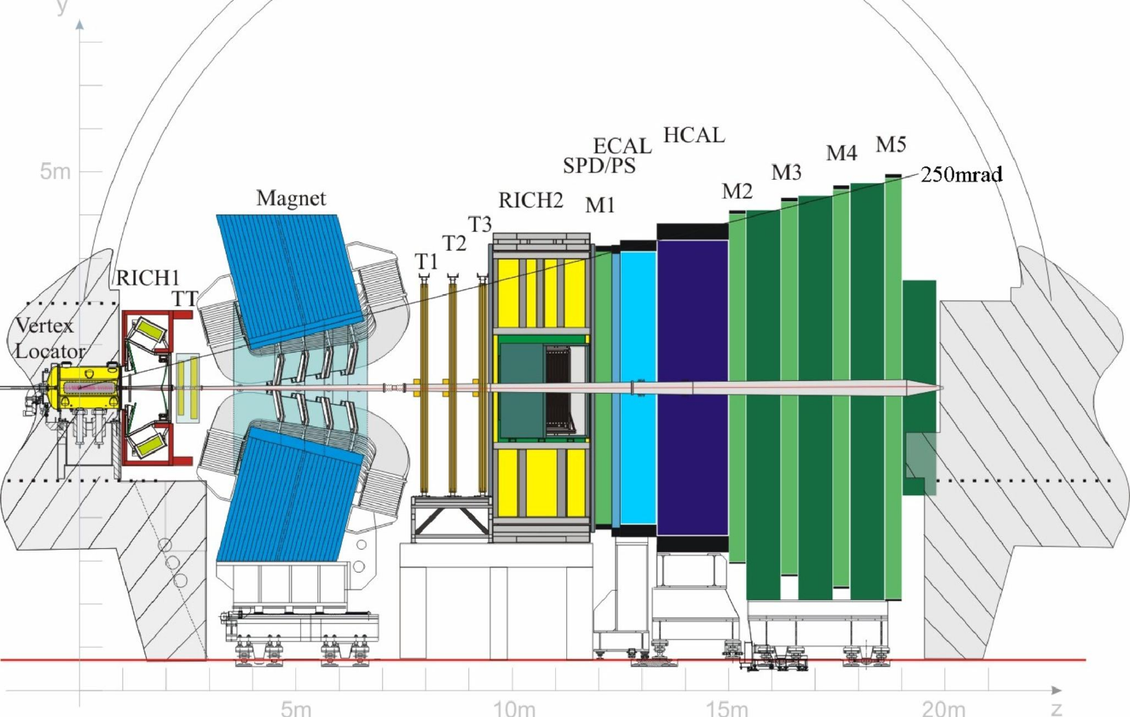

Figure: LHCb Detector diagram, taken from the CERN document server (<https://cds.cern.ch/record/1978280/plots>). Labels show detector layers.

There is a silicon detector inside the vertex locator that maps the reaction vertices to identify particle trajectories.

Magnetic field imparts velocity perpendicular to direction of motion

A secondary silicon detector then mapped the trajectories after the B-field and from the path change, the momentum could be accurately determined.

The Rich 1,2 detectors use Cherenkov radiation in different gases to find the velocity of the particle

Cherenkov radiation is a blue(always?) light that is emitted when the velocity of a particle is greater than the speed of light in that medium.

$$v> \frac{c}{n}$$

The Cherenkov radiation can be measured to determine the velocity of the particles.

Knowing the velocity and momentum gives us the mass of the particles.

Calorimeters ECAL HCAL measure charged particles and hadrons. They use iron to absorb particles and this releases photons (detected in scintillation tanks), to measure the energies of particles that reach this section. The ECAL absorbs charged particles, while the HCAL absorbs hadrons.

M1,M2,M3,M4 and M5 identify muons.

Neutrinos are not detected, one would need 4 lightyears of lead or a detector the density of a neutron star to detect them.

### 1.4 The decay

The decays that we will be analysing are:

$$B^{±} →h^{±} + R^{0}$$

$$B^{±} →h^{±} +h^{±}+h^{∓}$$

, where $h$ is a pion or a kaon and $R^{0}$ is a resonance (intermediate state that undergoes strong decay almost instantaneously, generating interference).

B+ contains up and anti-bottom, pions consist of up and down quarks (quark-antiquark pairs) and a kaon is a quark-antiquark pair of up, down and strange.

#### 1.4.1 Feynman diagrams of the decay

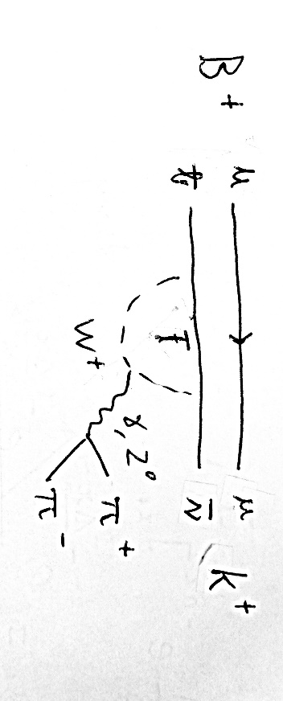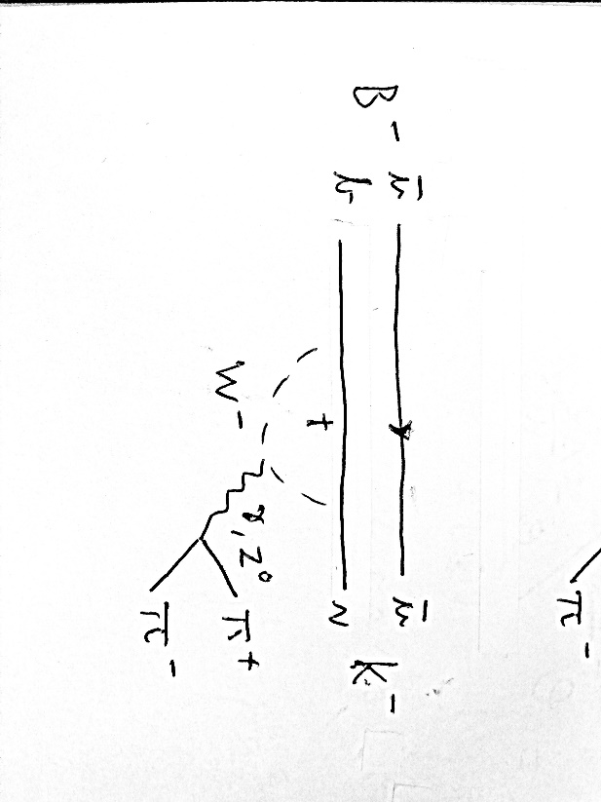

Example Feynman diagrams of various decays that we are interested in.

We will be evaluating the asymmetry:

$$A_{meas}=\frac{N^{-}-N^{+}}{N^{-}+N^{+}}=A_{CP}+A_{Det}+A_{Prod}$$

where N- and N+ are the reaction counts of B- decays and B+ decays respectively.

A(CP) is the asymmetry we want to evaluate, A(Det) is the detector asymmetry due to detection sensitivity to different particles and A(Prod) is the production asymmetry due to the reaction starting with only matter (pp collision).

We must also measure Dalitz Plot Asymmetries.

### 1.5 stuff

Extra stuff we can do: find the B lifetime, compare other decay channels..

### 1.6 Questions pre lab:

* 1st Vid 8:40 How do muons pass through the (ECAL) calorimeter chamber, while electrons and photons are absorbed? (possibly mass related)

Because they’re very heavy

* Need to look up/ask what needs to be in a lab book

There’s a document in the year 3 labs blackboard page detailing it

The ECAL and HCAL chambers “stop” particles by having iron absorb the particles. (scintillation light then gives an approximate energy reading)

## Week 1, day 1

09/02/2021

We were assigned to the $B^{±}→K^{±}+ π^{±}+ π^{∓}$ decay.

### 5.1 Getting Started

*Aim:*

* *Learn how to book, fill, save and plot histograms. Produce a plot of the probability that the final state particles are pions or kaons. You can find the list of variables in the appendix. Note that these variables are not filled in simulation, so run over e.g. 50000 events of collision data.*

First, I spent some time trying to get it onto spyder so I could look at the thing that keeps track of the variables but had difficulties importing uproot so decided it wasn’t worth the bother and just used the jupyter hub.

We made histogram plots of the P(K) and P($π$) separately. We can later use this to decide where our selection cuts should be.

Average probabilities:

|  |  |  |  |  |  |  |  |  |
| --- | --- | --- | --- | --- | --- | --- | --- | --- |
|  | Prob1K | Prob2K | Prob3K | Prob1Pi | Prob2Pi | Prob3Pi | ProbTK | ProbTPi |
| Mean | 0.115 | 0.148 | 0.172 | 0.517 | 0.532 | 0.445 | 0.145 | 0.498 |
| STD | 0.221 | 0.271 | 0.268 | 0.327 | 0.351 | 0.305 | 0.256 | 0.330 |
| Err Av | 0.001 | 0.001 | 0.001 | 0.001 | 0.001 | 0.001 | 0.001 | 0.001 |

Total Prob for Kaon = 0.154

A graph of the pion and kaon probability distributions of each particle.

A graph of the pion and kaon probability distributions of the particles in the dataset.

We are to choose a selection such that the particles chosen have a high likelihood of being a Kaon and two pions. So far we believe that P(K) > 0.85 and P(Pi) > 0.6 is reasonable by looking at the graphs. Anywhere between 0.3 and 0.7 seems reasonable for P(Pi) though.

We also made a code that calculates the mean probability of the particles, along with their standard deviation and standard error.

There is a strange matter with the event counter counting over the number of assigned values, despite returning the right number of values. Not caused by events being rejected before the counter ticks as the counter ticks before anything else. Also, it still stops the loop as soon as the counter reached the required number.

### 5.2 Invariant Mass Reconstruction

*Aims:*

1. *Produce a plot of the invariant mass of the B meson using the simulation data file. Assume that all final state particles are kaons.*
2. *Explain why it is better to rely on the measured momenta and assumed masses of the particles than their measured energies.*

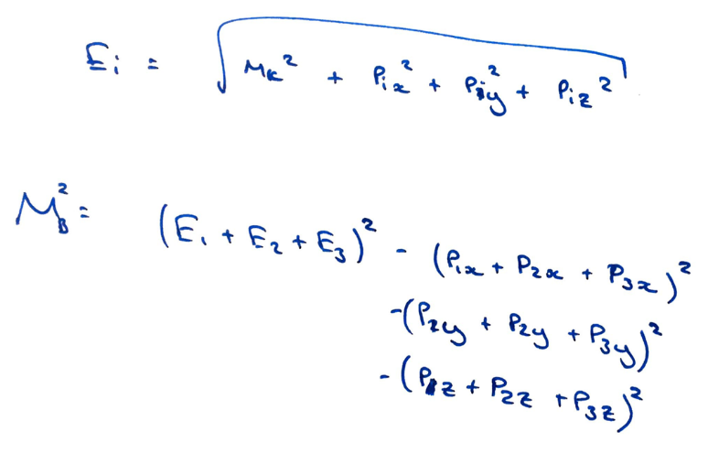

The derivation of the invariant mass formula for the B meson. This allows us to calculate the mass of the B meson. Assuming all three particles are Kaons we can test this on the simulated dataset, where it should give us a very sharp peak.

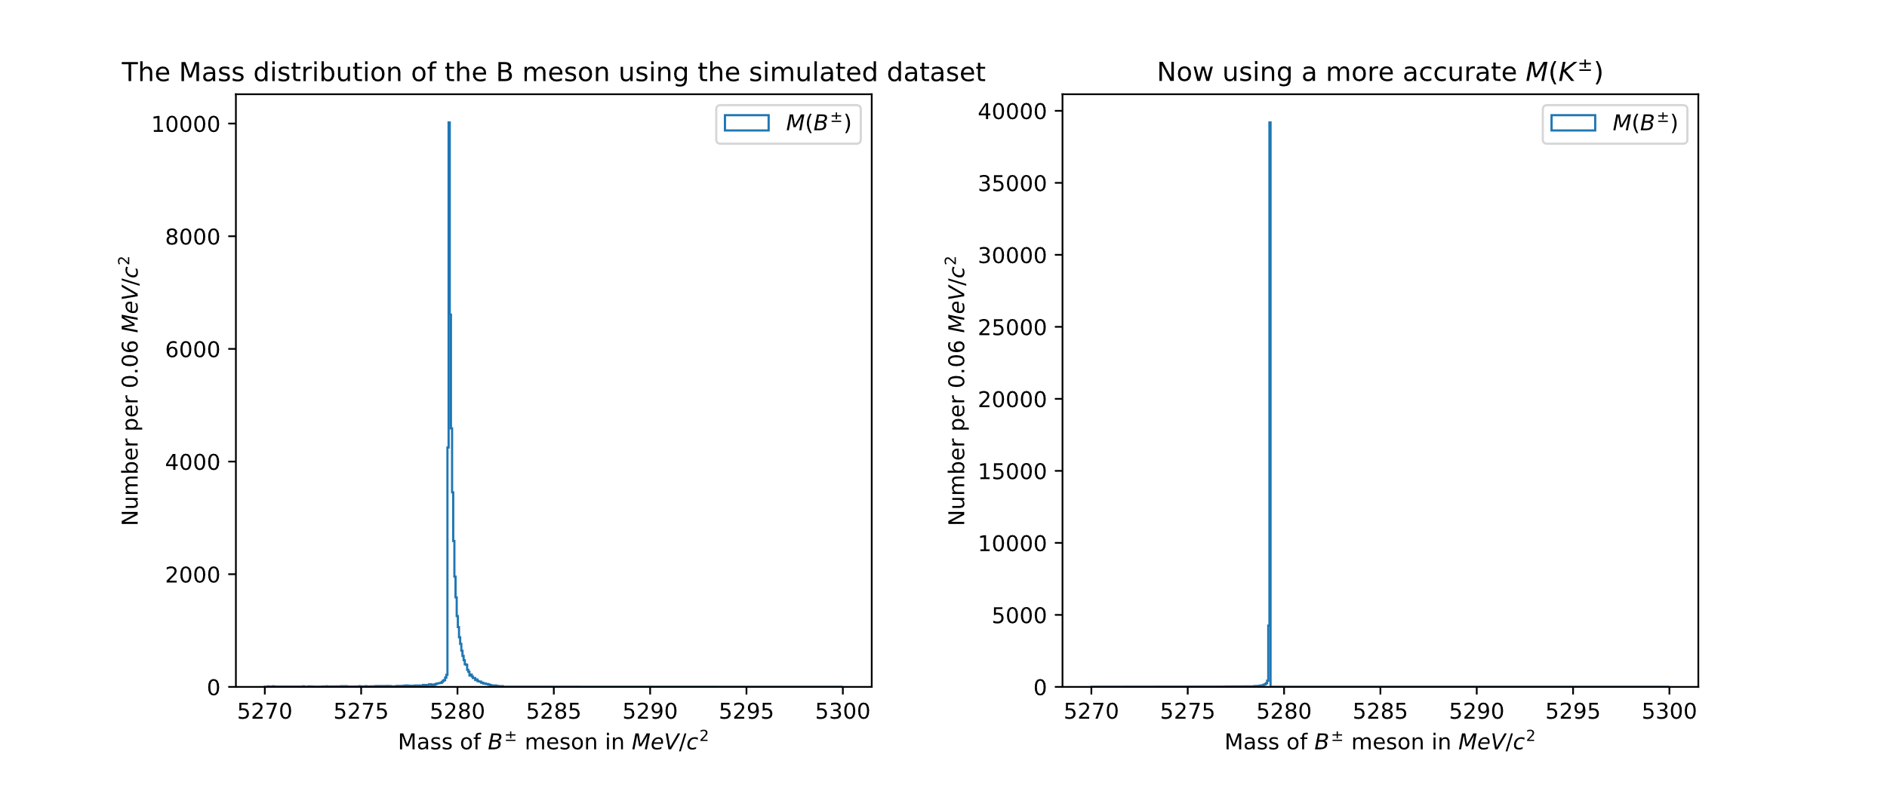

We used 494 MeV/c^2 as the Kaon mass which wasn’t quite accurate enough smearing out the peak. Upon changing this to 493.677 MeV/c^2 the peak looked much sharper. Dropping the c^2 in the lab book for convenience henceforth.

The sharp peak that was observed from the simulated dataset around the theoretical mass indicates that it was implemented well.

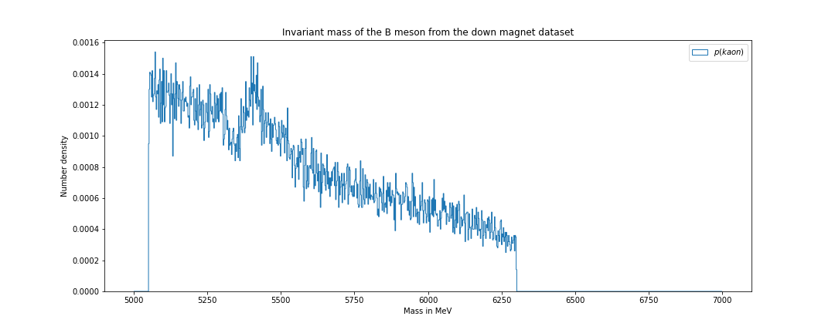A three-body invariant mass histogram from the down magnet dataset, a lot of noise, though there is somewhat of a signal observed around 5280MeV, the B-meson mass.

## Week 1, day 2

11/02/2021

### Table of particles

|  |  |  |  |
| --- | --- | --- | --- |
| Particle | Composition | Mass in MeV/c2 | Relevant Decays |
| $$π^{±}$$ | $$u\overline{d}$$ | 139.570±0.001 |  |
| $$K^{±}$$ | $$u\overline{s}$$ | 493.677±0.016 |  |
| $$ρ_{0}$$ | $$\frac{u\overline{u}-d\overline{d}}{\sqrt{2}}$$ | 775.26±0.25 | $$π^{+}π^{-}$$ |
| K* | $$d\overline{s}$$ | 891.66±0.26 |  |
| f0 |  | 990±20 |  |
| K*0 |  | 1414±15 |  |
| D0 |  | 1864.83±0.05 | Several combinations of Pions,  Kaons and resonances. |
| $$J/ψ$$ | $$c\overline{c}$$ | 3096.900±0.006 | $$μ^{+}μ^{-}$$ |
| $$χ_{c0}$$ | $$c\overline{c}$$ | 3414.71±0.30 | $$π^{+}π^{-}$$ $$K^{+}K^{-}$$ |
| $$ψ(2S)$$ | $$c\overline{c}$$ | 3686.10±0.06 | $$μ^{+}μ^{-}$$ |
| $$B^{±}$$ | $$u\overline{b}$$ | 5279.29±0.15 | $$K^{±}π^{+}π^{-}$$ $$π^{±}π^{+}π^{-}$$ $$K^{±}K^{+}K^{-}$$ $$R^{0}+h^{±}$$ |

For ease of reference. Probably should have done this before, oh well.

Update from shared docs

### 5.3 Selection Cuts

*Aim:*

1. *Select the sample of events for the channel that you will study using particle identification information.*
2. *Show that a clear mass peak is observed in the data for the B± once the correct mass hypotheses for the final state particles are assumed. Identify that there are regions in the mass plot dominated by signal events and regions dominated by background (known as side-bands).*
3. *Discuss why the signal peak appears to have approximately the shape of a Gaussian distribution.*

We applied cuts to the data to find decays that had a strong possibility of being a Kaon and two Pions, a KPiPi decay. This was done by using a logic flow where it checked for which particle had the greatest probability of being a Kaon. It then checked whether the probability of it being a kaon was over a certain amount, which we set as 0.85 for now. Then it checked whether the other two particles had greater than 0.6 probability of being a Pions.

We also applied a cut where the total number of charges had to add up to 1, which didn’t cut anything out telling us that the data was already filtered out for this. Also, the charge of the Kaon had to be equal to the overall charge and therefore the charge of the pion. Another way of putting this is that the charges of the pions had to add up to 0.

We also applied another cut where none of the particles could have been identified as muons.

Only then was the data accepted for further analysis.

Plotting the three-body invariant mass as a histogram gives us this graph.

There is a clear peak observed around 5280MeV, the mass of the B-meson. These would be the signal events. There is another shape that looks somewhat gaussian centered at around 5050MeV, this is the 4-body background. It is caused by the B-meson decaying into 4 particles, only 3 of which are picked up/selected by the detectors. The noise in the area 5500MeV and above is the combinatorial background, it is caused by the many other particles found in the beams when the protons collide.

The peak of the B meson signal peak was a gaussian because of the uncertainty from the detectors. Also, if the detectors were perfect it would still be a gaussian due to the particle width. It has an inherent uncertainty in energy due to Heisenberg’s Uncertainty principle, although this is much smaller than the contribution from the detectors due to the long lifetime as the B meson decays via weak decay.

$∆E ≈\frac{ħ}{Δt}$.

### 5.4 Two-body Resonances

*Aim:*

* *Plot the two neutral two-body invariant mass distributions and identify the two-body resonances in the data for your decay channel.*

We calculated the two body invariant masses of the Kaon and the pion with the opposite charge as well as the two pions. We also made a rough cut around the B-meson peak of 5280 $±$ 100 MeV. and plotting these the following graph was made.

Note: Whenever I write K or P or Pi or $π$, including in the graphs, I mean $K^{±}$ and $π^{±}$.

The graph of the two body invariant masses of K $π$ and $ππ$, Shows a very large peak at around 1850Mev, due to the D0 resonance. Looking at the pdg for D0 decays, the D0 resonance decays into Kπ much more (10^3 times) than the ππ so a significant ππ signal is not observed at 1864MeV.

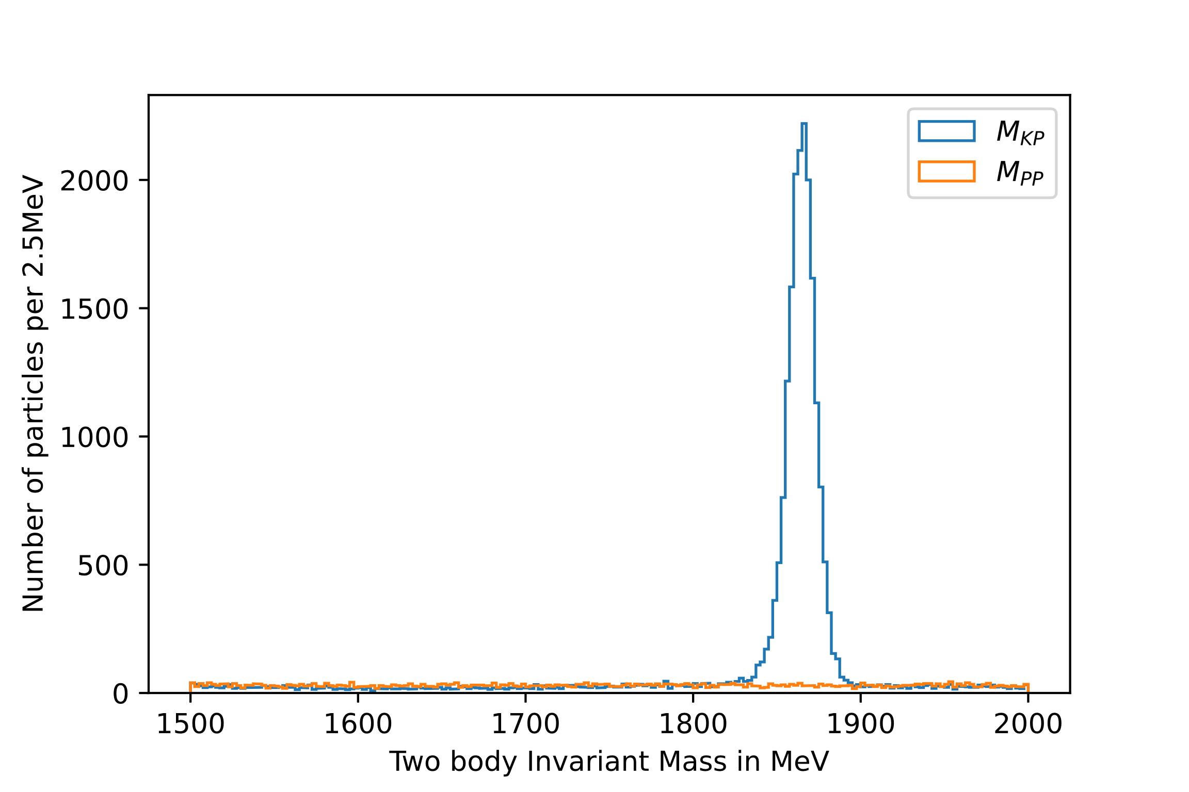

The same graph shown closer to the D0 peak.

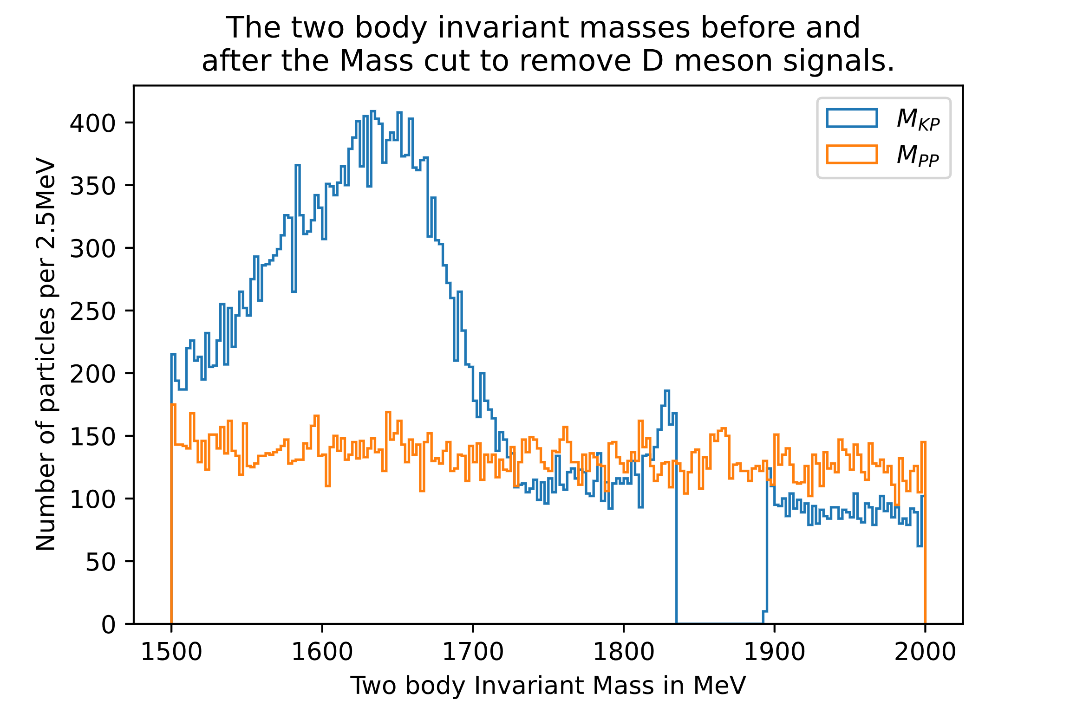We then cut out the contribution from the D0 meson by removing events with an invariant M(K $π$) mass of 1864.83 +- 30 MeV.

There is still some D0 signal remaining to the left of the cut, so we decided to try moving the centre of the D-cut a little to the left.

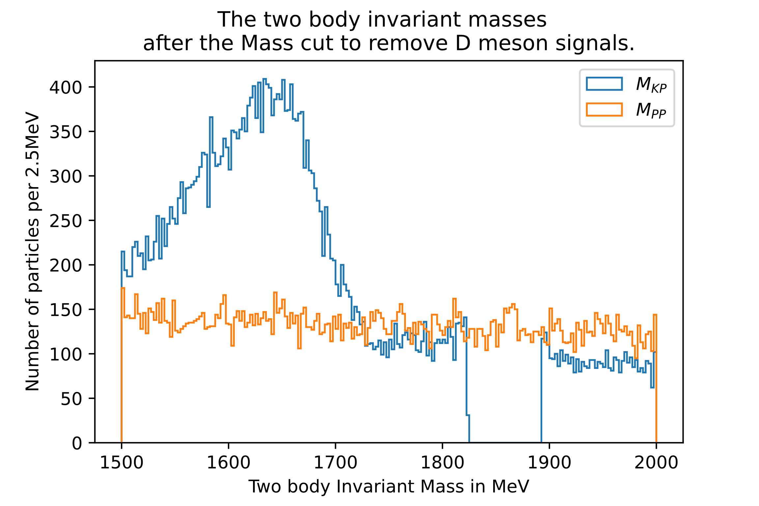

We changed the cut to be centered slightly below the D0 mass. The cut was changed to 1858±35MeV. It is apparent most of the D0 signal was removed.

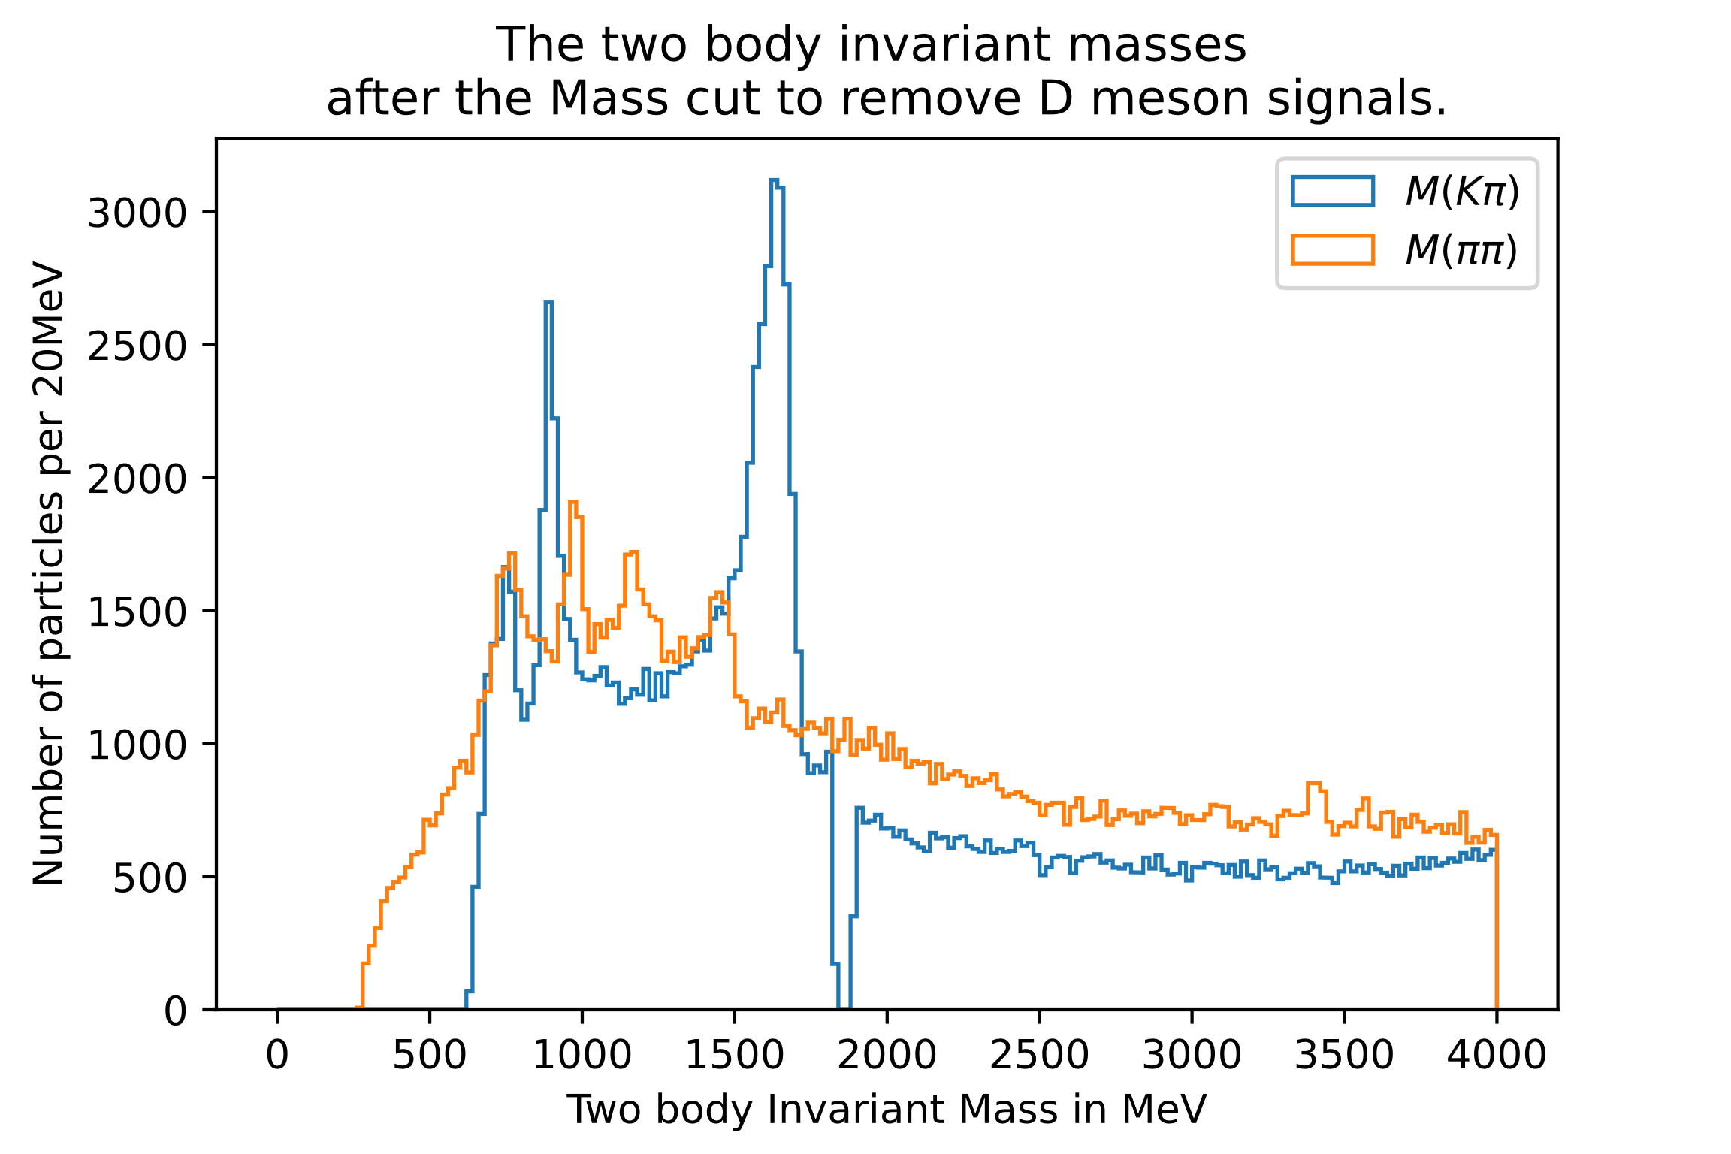

The Jpsi decays into two muons which are both misidentified as pions. The Jpsi has a mass of around 3000 MeV, and would have been observed in the M($ππ$) plot at around 3000MeV. It’s not visible so we haven’t made a cut for it.

We need to analyse the other peaks further, but it came to the end of the day so we’ll leave it for later.

## Week 2, day 1

16/02/21

### 5.5 Global CP Asymmetry

1. Fit the 3-body invariant mass distribution with an appropriate model and determine N ± from the number of events contributing to the peak around the nominal B mass for the B± sample, respectively. Calculate the global CP asymmetry. Have you found evidence for CP violation?
2. Derive the statistical uncertainty for the asymmetry.
3. Discuss the limitations of the formula in (2) as this only considers signal events.

The derivation of the statistical uncertainty.

The caveat when using this is that there are events from the combinatorial background that are neither a B+ or a B- decay, meaning that the asymmetry is not a binomial distribution. There might be a slight skew to +vely charged particles because the particles being collided are protons which obviously have a +ve charge. There is also a possibility of skew in the particles that are detected, where it’s more likely to detect particles of a certain charge.

To the three body invariant mass diagrams, we applied a fit using an exponential plot for the background noise, a gaussian for the B peak and a gaussian for the four-body combinatorial. We then separated the data into B+ and B- and fitted those to find the relative area under the curve for each gaussian fit for the B peak. The relative number of events for each were proportional to the normalization constant, the ratios of which give the asymmetry.

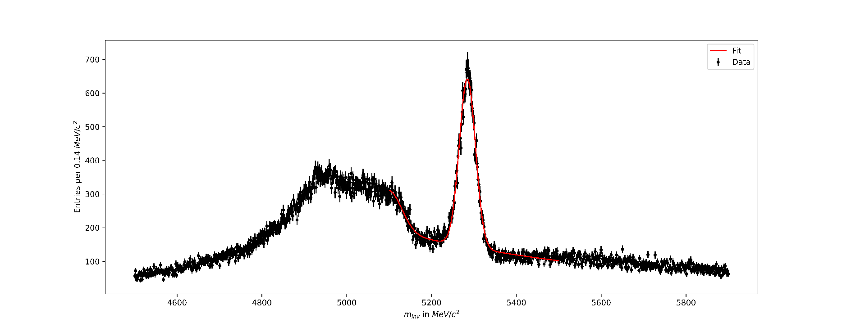

EDIT: The Y axis should read per 1.4 MeV/c^2. Will show up in a few graphs of the B

The EDIT thing is me going back to annotate my lab book

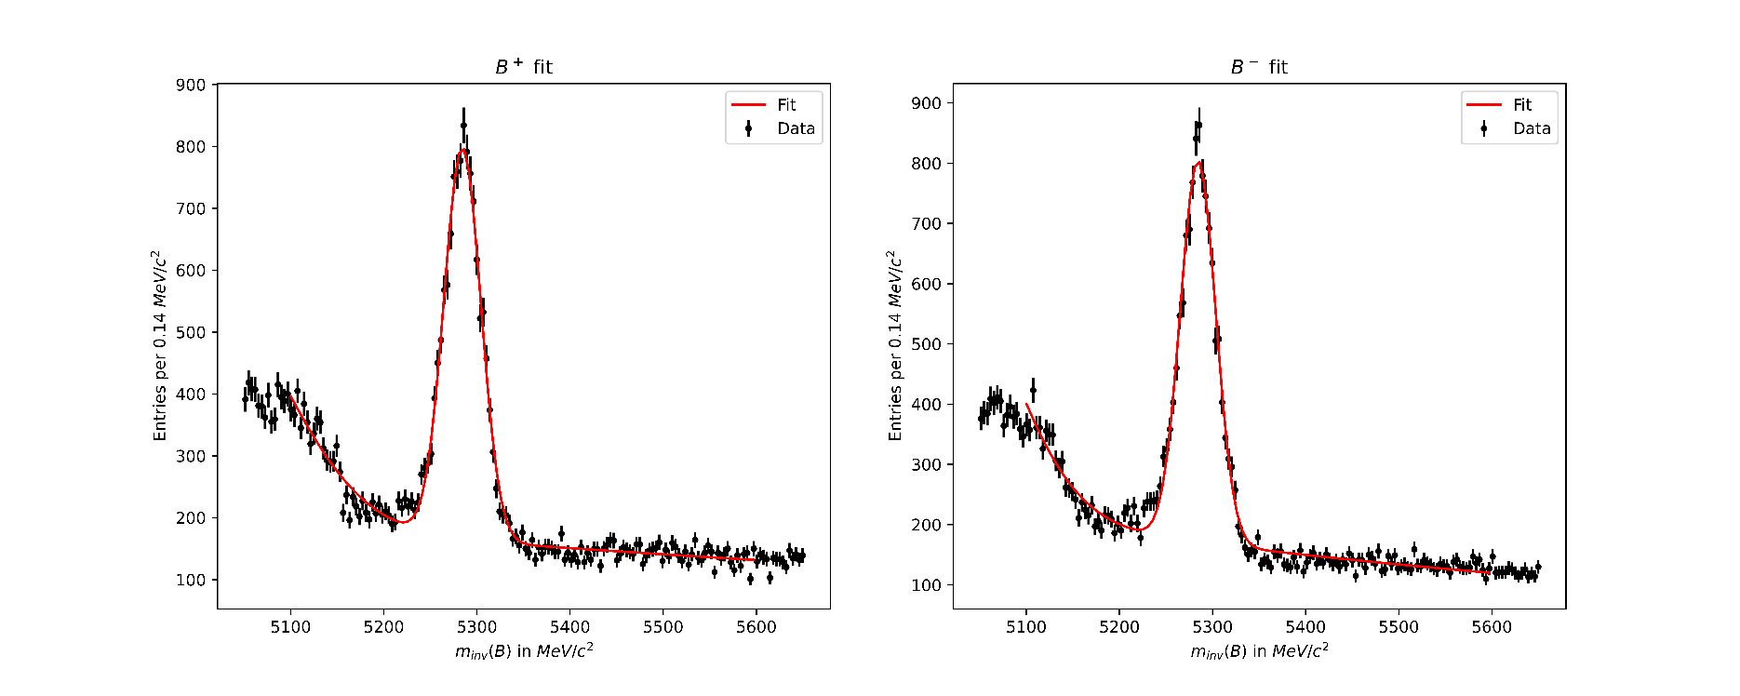We repeated the fit after separating the data into B+ decays and B- decays.

We found the fitted variables to be:

|  |  |  |
| --- | --- | --- |
| Name | Value | Uncertainty |
| Mean/centre (B) | 5284.489970 | 0.189351 |
| Gaussian Spread (B) | 19.011324 | 0.207164 |
| Normalization (B+) | 30163.138954 | 498.369369 |
| Normalization (B-) | 29486.883979 | 459.271074 |
|  |  |  |

This gave us an observed global asymmetry of -0.0117±0.0041 or -1.2±0.4%.

This was not a particularly significant asymmetry as the systematic uncertainties are on the order of 1 percent. This is expected over the whole phase space and larger asymmetries should show up when looking at local asymmetries. We will now attempt to analyse the local asymmetries using Dalitz plots.

### 5.6 Dalitz Plots

Aims:

* Produce a Dalitz Plot for the data sample you are analysing.
* Produce a Dalitz Plot which describes only the signal events in the data sample by subtracting the background.
* Revisit your identification of two-body resonances and observe how they are distributed on the Dalitz Plot.

It took us a while to write the code for the histograms, but we managed without much difficulty.

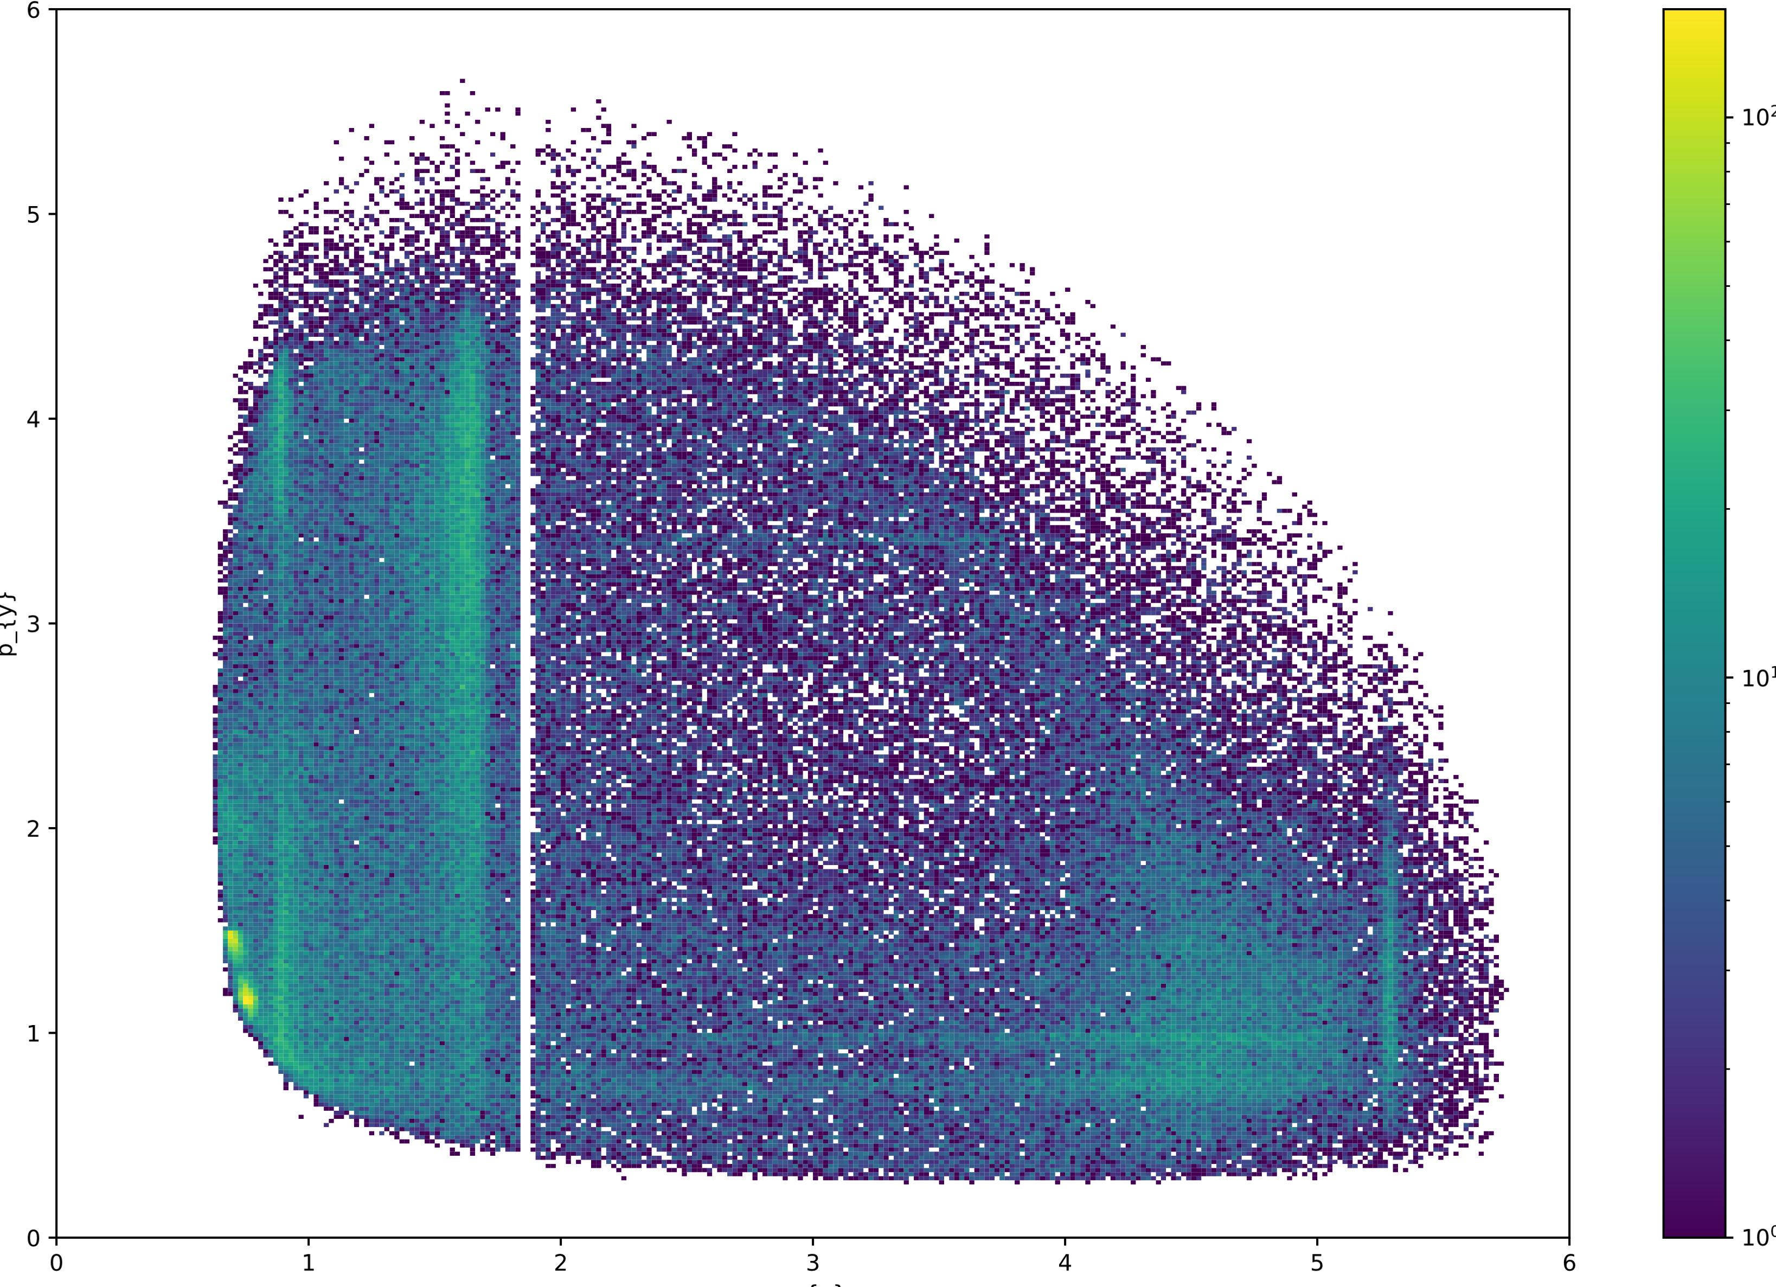

A Dalitz plot over a very range using very small bin widths, plotting the probabilities with invariant masses on the axis (not the squared invariant masses as we are supposed to). Made without selecting events around the B-mass.

Only included it as it looks very pretty. The resonances that decay into a Kaon and a Pion appear as vertical bands, and the resonances that decay into a Pion Pion pair appear horizontally. The D0 cut we applied appears as the vertical white gap.

EDIT: Should read bin widths of 0.33GeV x 0.33GeV in the title

Drawn a Dalitz plot of plus minus 4 sigma around the peak of the fitted B mass. Where sigma is the spread of the gaussian (not the uncertainty of the fit!).

Drawn a Dalitz plot of the background (mostly exponential) from B mass of 5400MeV to 5800MeV. Integrated the exponential to find the area under it from 5400 to 5800MeV (A1) and under the B mass +- 4sigma (A2).

This gives us the relative strength of the background(exponential) present in the Main Peak plot. We can multiply the background plot by A2/A1 and subtract from the main peak plot to remove the background(exponential) from our plot.

We removed all the bins that had a negative value from the histogram.

I think we can repeat this for the 4-body to find the 4-body signal and then remove that from 2.1.1 too. Though how much point there is to this depends on the overlap of the two gaussians. I will integrate the combinatorial gaussian in the range (B mass +- 4sigma) to find whether we should later do this.

### To look into:

* Research what causes the 4-body in more detail
* The effect of amplitudes/phases in this decay
* Find out how to find out what the systematic and other uncertainties in the LHCb experiment/our data was.
* Draw all the Feynman diagrams of these decays
* Make plots of the other two (KKK, $πππ$) afterwards

## Week 2, day 2

18/02/21

### 5.4 Two body resonances continued

You can see in the Dalitz plot Jpsi at 9GeV^2 and another resonance in the M($ππ$) band at around 12GeV^2. Couldn’t see it before in the 1D histogram plots but they’ve shown up now so we can make a cut of the Jpsi.

The reason they couldn’t be seen in the 1D histograms was because I forgot to only plot the events around the peak by making a cut around it. They are now clearly visible in the 1D plots.

We weren’t to sure about the particle at 3400 as it seems to have a spin in the Dalitz plot that doesn’t quite match up with the one for chi c0. We think it may actually be a Psi 2S with muons being misidentified as pions

To test this, we drew the Minv($ππ$) using muon masses so it became Minv(MuMu) to check whether the particle at 3400 was actually a Psi 2s but it barely moved and we decided that it was actually the chi c0. The chi c0 is charm anticharm so we made a cut to remove it as we are looking at charmless decays.

The other peaks that showed up in the 1D histograms have also cleaned up nicely.

There is a small peak in the $ππ$ plot at 775MeV that is the $ρ^{0}$ resonance, a larger peak at 890MeV in K $π$ that would be the K* resonance, and another large peak at 990MeV in $ππ$ that is the $f_{0}$ resonance. All the resonances match up to what is expected.

### 5.7 Local CP Asymmetry

Aims:

* Produce plots to show CP Violation across the Dalitz Plot.
* Identify any regions in which you find significant evidence for CP Violation. Determine the magnitude and significance of the CP Violation.
* You should produce three Dalitz plots: the asymmetry, the error on the asymmetry, and the significance

We plotted a Dalitz plot of the asymmetry by separating the data into two one for B+ and one for B- and simply plotting events for those with their respective backgrounds removed. We then used the asymmetry formula and plotted it.

The graph started looking like this where the backgrounds values were all 0 so they were plotted as green instead of clear/white.

It was incredibly frustrating trying to get a white/clear background for the regions on the outside to make the graph look better but I managed eventually using

cmap1 = copy.copy(mpl.cm.get_cmap(“viridis”))

cmap1.set_bad(‘white’)

and setting zero values to NaN which seems really questionable in terms of coding etiquette but works so it’ll do for now.

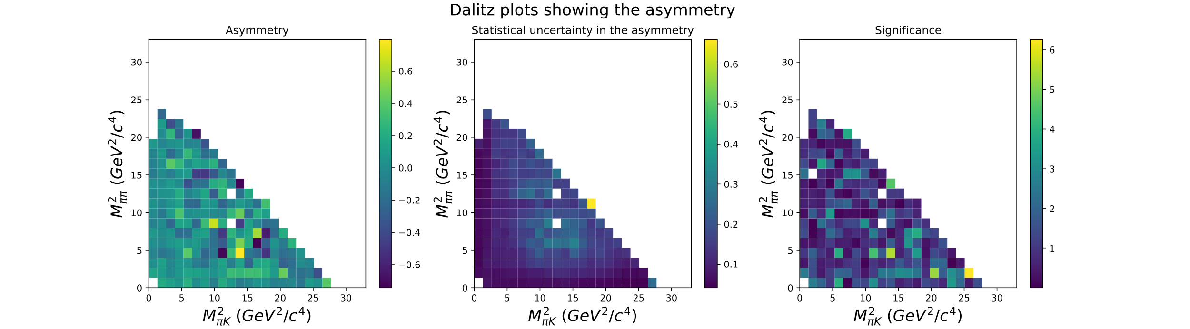

We also plotted the systematic uncertainty and the significance. Where the significance was the result divided by the systematic uncertainty. We should include the other uncertainties in the plots later probably.

We should experiment with other colours that show the uncertainty better as the one very large result makes the others look the same, most noticeably in the statistical uncertainty plot(middle).

We’ve pretty much done most things in the lab script up to section 5.8 further work so we need to start thinking about what else we should do over the weekend

### To do:

* Leftover points from before
* Make a plot that shows the components of the fit (the two gaussians and the exponential) and the sum
* Try variable bin widths
* Include other uncertainties into the significance plots?
* Read up more on what else can/should be done

## Week 3, day 1

23/02/21

### 5.8 Systematic Uncertainties and Further work:

It was around here where we pretty much did everything in the lab script and started trying to improve our analysis/code independently.

We experimented with variable bin widths but didn’t get very far as we moved onto other things for now. We want to get our asymmetry plots to look like the ones that are published in some publications ideally. [1][4]

### 5.8.1 Crystal Ball fitting

When the charged particles go through the magnetic field, they experience acceleration perpendicular to their direction of motion $\vec{F}=q(\vec{v} ×\vec{B})$. When charged particles accelerate, they emit light as bremsstrahlung radiation. This reduces the energy of the particle, giving the gaussian distribution a tail.

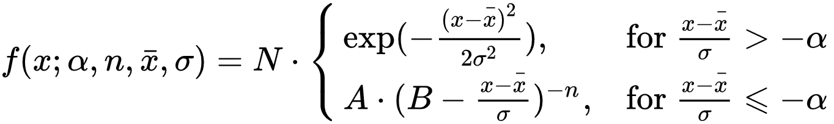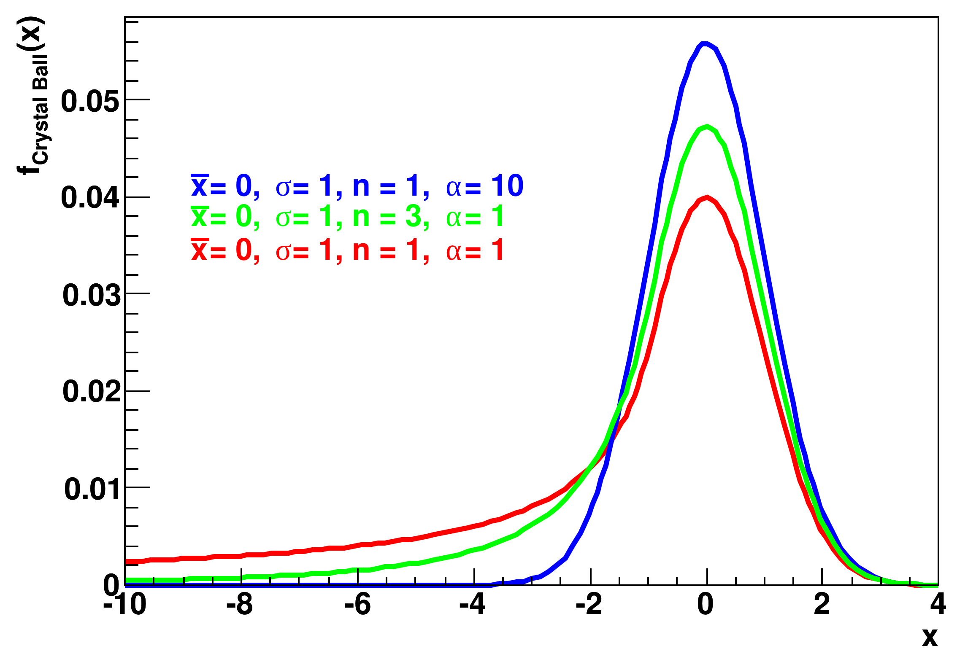

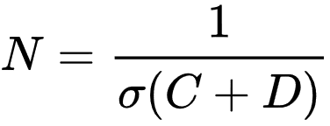

(plot and equation taken from wikipedia [2].)

We also considered using an ARGUS function convolved with a gaussian [1] for the fit but didn’t for now as the convolution would be a headache and it would have a minimal effect.

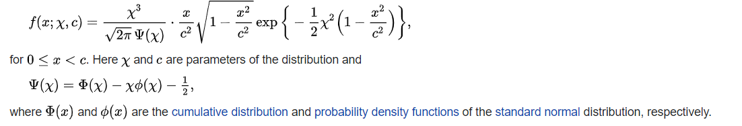

The definition of the ARGUS function [2].

This took most of the day to implement due to a lot of debugging and trouble with scipy.optimize().

Noticed that our old fit the axis on the left should read per 1.4 MeV instead of 0.14 and in retrospect there were too many bins used.

Our new fit. It’s clearly a lot better than our last, especially around the tails. We also reduced the number of bins.

It’s still not quite right, but we’ve been working on this for 6-7 hours now and we’re going to move onto something else for now.

### 5.8.2 Production and detection asymmetry

We also started trying to find the detection and production asymmetries. This can be done by looking at the Jpsi asymmetry we have detected and comparing this to the published values of Jpsi asymmetry.

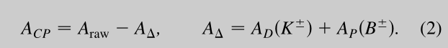

(taken from ref 16 in the lab script [1].)

We started analysing the Jpsi asymmetry by inverting some of our selections(muons) to find Jpsi decays. Jpsi decays take the form $B^{±}= K^{±}+μ^{+}+ μ^{-}$. Therefore, we selected events with two muons and plotted the two body invariant masses of the MuMu and KMu.

It shows a very strong peak around 3100 the Jpsi mass and a smaller one around 3700 the Psi(2s) mass. Jpsi decays into muons about 6% of the time and whereas Psi(2s) decays into muons about 0.8% of the time so it makes sense that it has a much larger peak. Jpsi is probably produced more too (may be worth looking into).

It was 5pm so we left it here for now. We still need to find the asymmetry of the Jpsi and compare to the published values.

### To do:

Momentum cuts still?

Variable bins

Continue the Jpsi asymmetry

Other leftovers from previous ‘To Do’s

Partial decay widths and CPT conservation

## Week 3, day 2

25/02/21

### Crystal Ball Fitting Continued

We went back to working on our crystal ball fit, fitting onto the Jpsi data for the moment.

Fixed more errors in the crystal ball:

* The uncertainties before were too large to be reasonable (should have been $≈\sqrt{N}$).
* We were using the normalization constant (which is the area under the crystal ball) as the number of events whereas we should have been using the normalization constant divided by the bin width. Makes sense since we haven’t normalized the Y-axis to give events per MeV.
* Plotted a crystal ball in geogebra to help us check our function. Saved as crystal_ball.ggb in /lab folder.
* Integrated a crystal ball function using scipy to check it was normalized to 1. It wasn’t which helped find an error in how the equation was written.

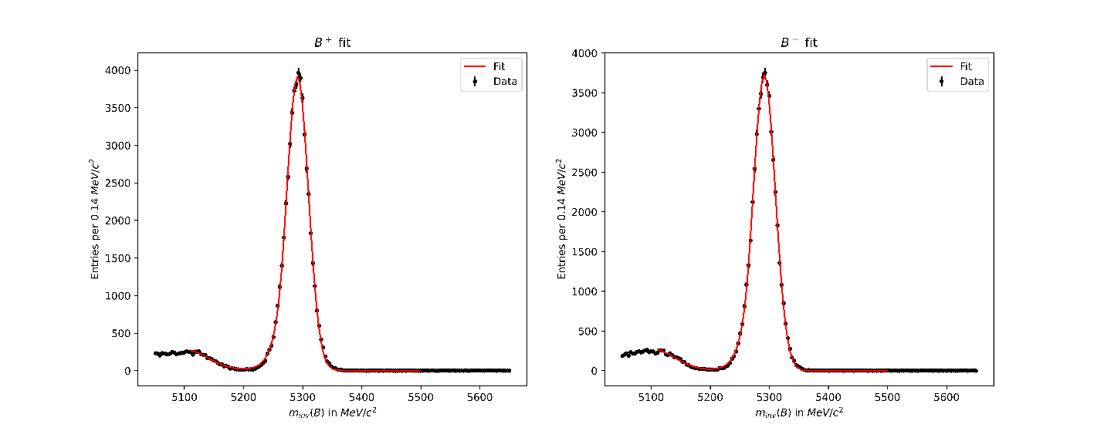

Finally, we got something decent.

Should say 1.4MeV on the Y-axis, and we did a little more work on it in Week 4 day 2 (02/03/21).

### Production and detection asymmetry continued

Going to continue working on the Jpsi asymmetry for now, as a side note there are more K $μμ$ datapoints that have a three-body invariant mass within 4 sigma of the B+- invariant mass. Means that the signal peak is a lot stronger compared to the background as can be seen from the graphs of the fits.

|  |  |  |
| --- | --- | --- |
|  | Kππ | K $μμ$ |
| After selecting events with a high likelihood of the right decay | 191408 | 170713 |
| After selection around the B+- peak | 33062 | 116048 |
| After selection of the Jpsi in the two-body invariance | N/A, 33062 | 103851 |

This allows us to make a measurement of the detection and production asymmetries that is more accurate.

**Asymmetries (Jpsi)**

|  |  |  |
| --- | --- | --- |
|  | Value | Uncertainty |
| events under B- peak (fit) | 45289.468 | 217.5517 |
| events under B+ peak (fit) | 46998.977 | 265.749 |
| Resultant Asymmetry (fit) | -0.021615 | 0.0071 (statistical + fit) |
| Count for B+ | 50831 |  |
| Count for B- | 53039 |  |
| Resultant Asymmetry(count) | -0.0212516 | 0.003102 (just statistical) |

The uncertainties of the fit on the events are about what they should be at around $\sqrt{N}$.

the published asymmetry used was 0.1±0.7 % [1].

Using the formula

we calculated our detection and production offset to be -2.26±1.0% rounded to -2.3±1.0%

The uncertainty in the fit was propagated with the uncertainty for the global average to get 0.99% rounded to 1.0%. (Note: repeat this with a more recent global average)

We also investigated partial decays widths of the B+- which are something like the probability per second of each decay happening. When divided by the total probability per second of decay as is given in the pdg(particle data group) then it tells up the relative abundance of the decays. The partial decay widths for Kππ and KKK should cancel out according to [1] due to CPT conservation(check!). This will be reflected in our data as their asymmetries.

We should measure how good our selection criteria are by varying them and trying to maximising signal events whilst minimizing background events.

### To do:

* Variable bins
* Momentum constraints
* Fitting local CP asymmetry significance for Jpsi and fitting a gaussian onto the histogram
* Maximising the main peak signal and reducing the background signal by varying out P(K) and P(P) constraints.

## Week 4 day 1

02/03/21

Continuing on from last week, I now realise that the CP asymmetry of decays with the same final state quantum numbers must sum to 0 due to CPT conservation. This probably means that there are more than just KKK and KPiPi that sum to 0. I will look into this further if we have time.

We are going to further work on our curve_fit.

The fit was a good one (reduced chi squared of about 1.15 160/140) but the uncertainties on the parameters were very, very large, we think this was because they are interlinked so it can be fitted with a large n or a large norm constant for example. We fixed this by setting some of the parameters such as n and alpha to the fitted ones 1.5 and 1.1 for our case. This helped with some of the problems. We also fixed the offset of the exponential to 0. This fixed the issue with the uncertainties.

Interesting this problem didn’t occur with the muon dataset for Jpsi. I think this was because the signal peak was much larger relative to the background and there were more data.

### Analysing the Local CP Asymmetry Plots

To check for whether our results for the local asymmetry are significant, we can plot the significances of each bin on a histogram. We can then fit a gaussian onto this graph, if there was no local asymmetry, we would expect a gaussian with a sigma (spread) of 1. The mean of the gaussian would probably be the global asymmetry but the data may not be accurate enough to recreate this.

Looked into keeping bins that had a significance of very close to 0 as we were previously removing them along with all the empty bins. One good thing about setting the bins to np.NaN before in (5.7) was that it meant that the bins outside of the Dalitz plot weren’t plotted in the histogram of the significances.

First, we decided to try experiment with different colourmaps that display the colours better. We also set the colourmap for the significance to go from the largest absolute values to minus the largest absolute value. This ensure that the values near 0 on the colourmap always have the same colour.

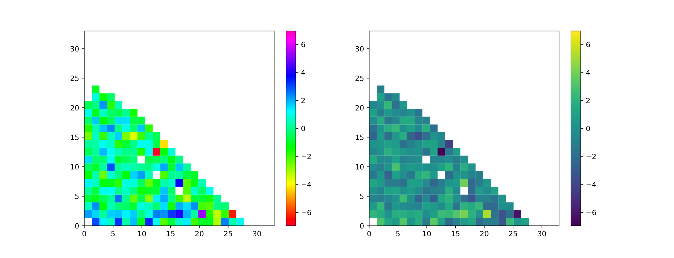

In the end we decided to use cmap = ‘gist_rainbow’.

It wasn’t ideal but it shows off a lot more of the structure than the others. It’s a little rough on the eyes though.

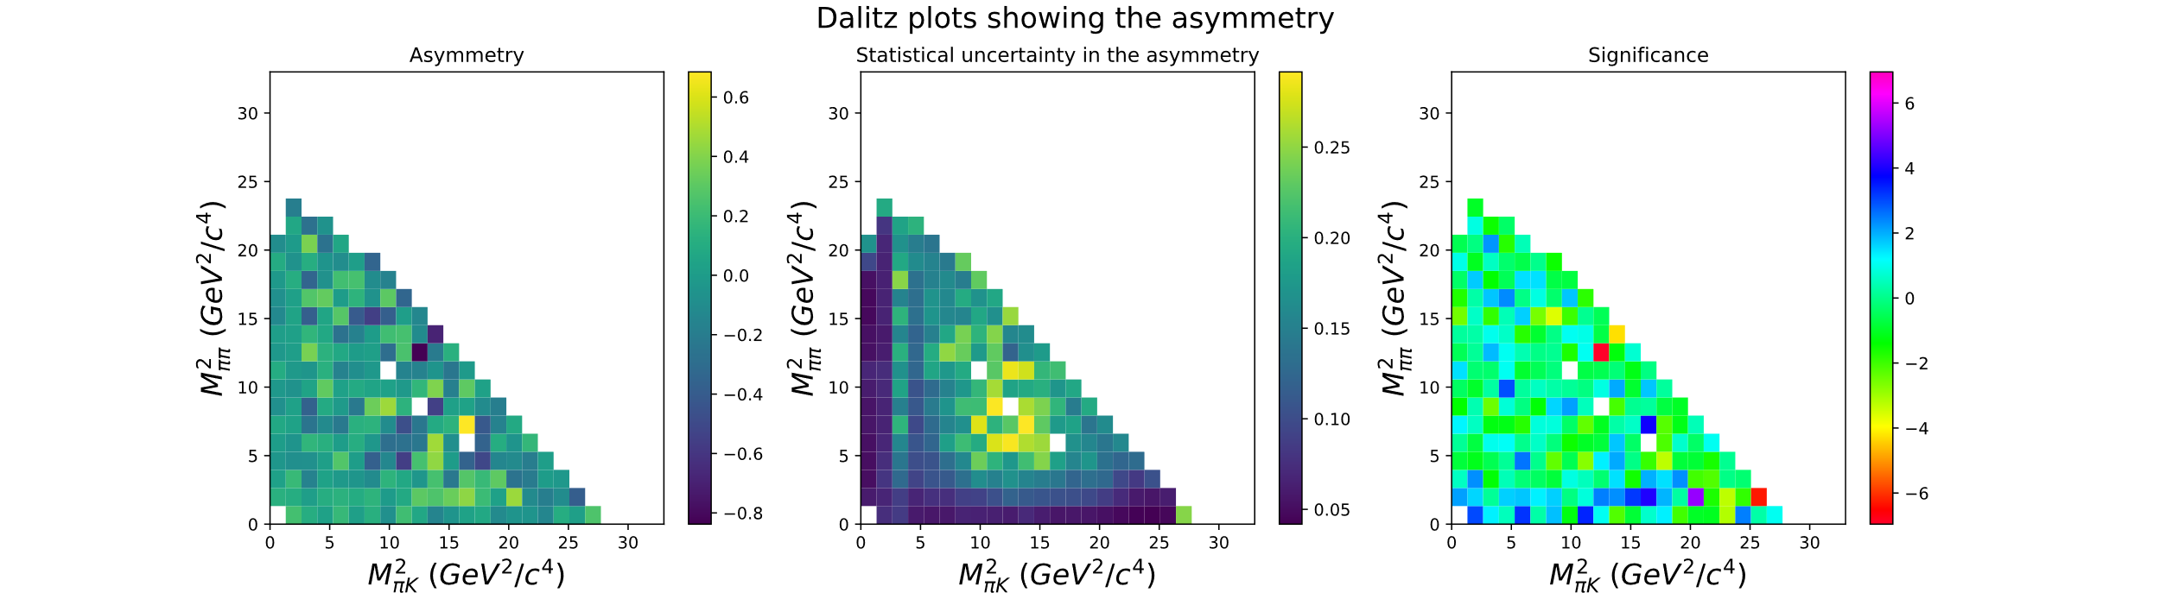

We took all the significances for each part of the Dalitz plot and plotted them in a histogram and fitted a gaussian onto it.

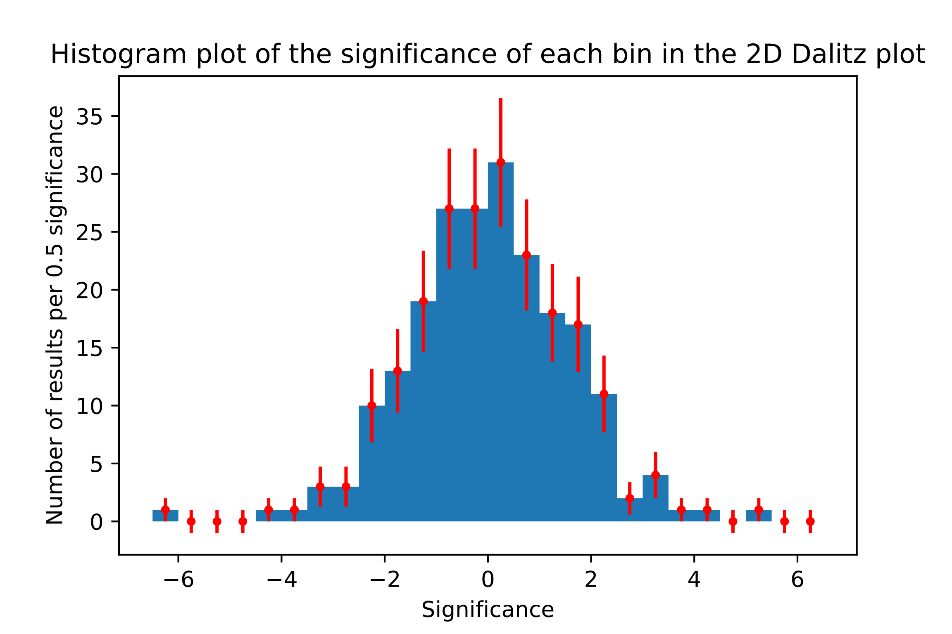

The error for the value of each bin was $\sqrt{N}$ as it’s a Poisson distribution. May want to check that’s correct and there isn’t another one to account for. Could add in horizontal uncertainties but I’m not sure SciPy can handle them.

Apparently, there is also an idea that because the gaussian isn’t evenly distributed throughout the bin, we can integrate the gaussian and find a CoM for each bin. Then we use that instead of the centre of each bin. This would take a very long time and I highly doubt that it would change it overall. Could research more if we finish everything else.

|  |  |  |
| --- | --- | --- |
|  | Fitted value | Uncertainty |
| Normalisation | 204.12 | 14.29 |
| Actual # of bins used | 215 |  |
| Mean | -0.0187 | 0.0996 |
| Spread | 1.4121 | 0.0756 |

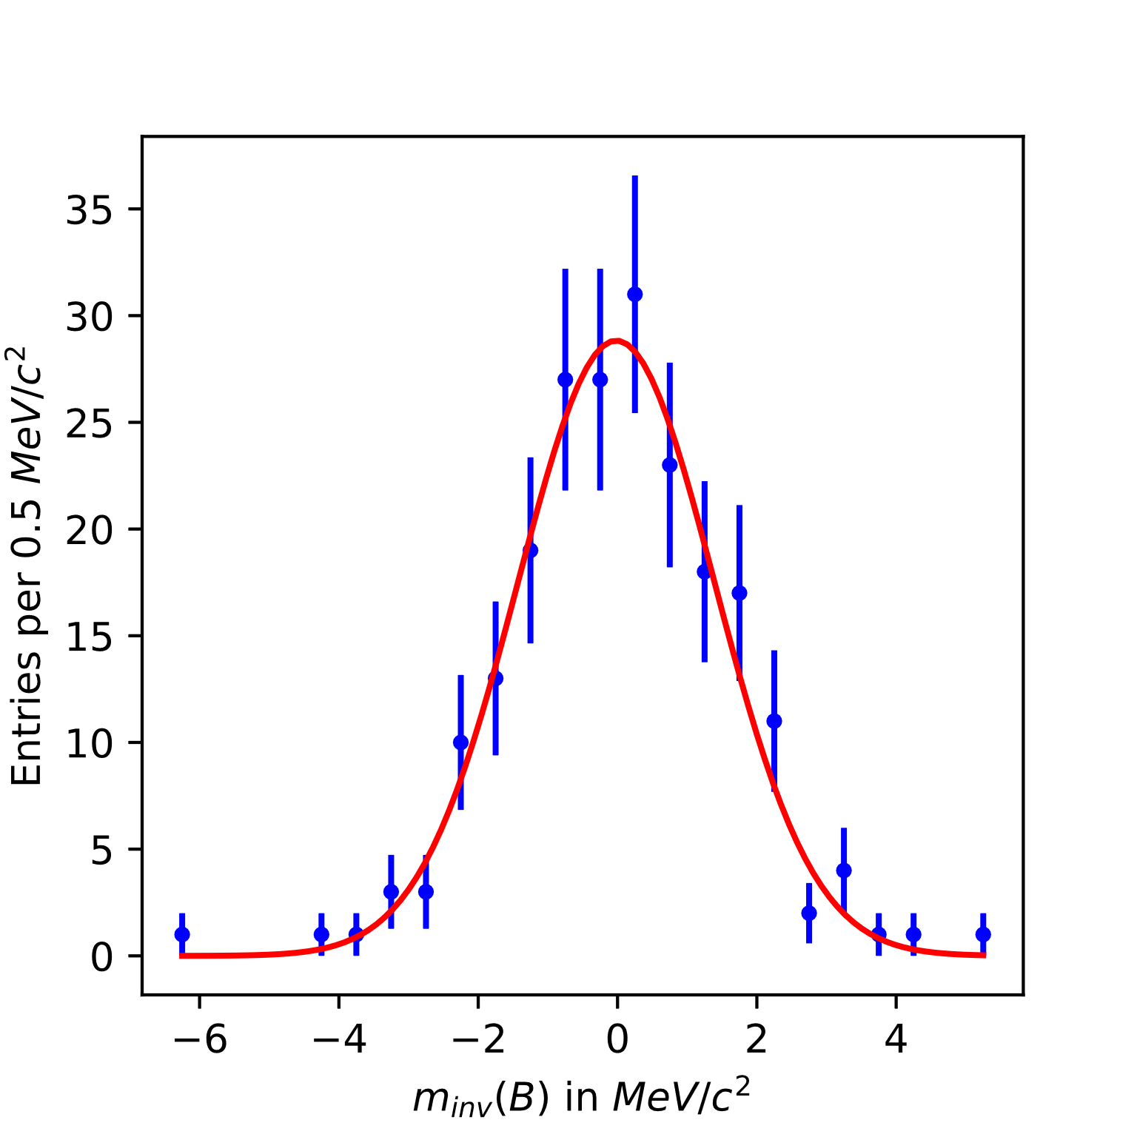

The X-axis should read significance (sigma)

Our fit of the gaussian and the fitted parameters.

The spread is about 5.45 sigma above what we would expect for no underlying CP asymmetry which is a spread of 1.

We thought that we were using too many bins and wanted to try to reduce the uncertainty on each bin in the asymmetry Dalitz plot by reducing the number of bins. The lab script recommends bins of about 2.5GeV x 2.5GeV.

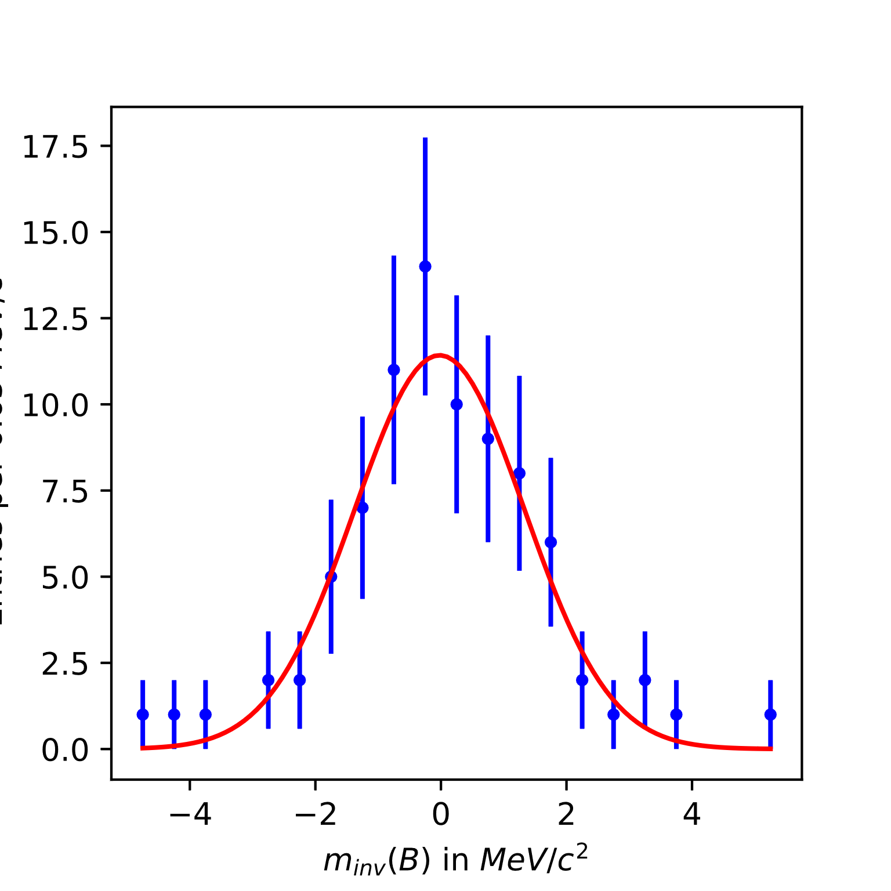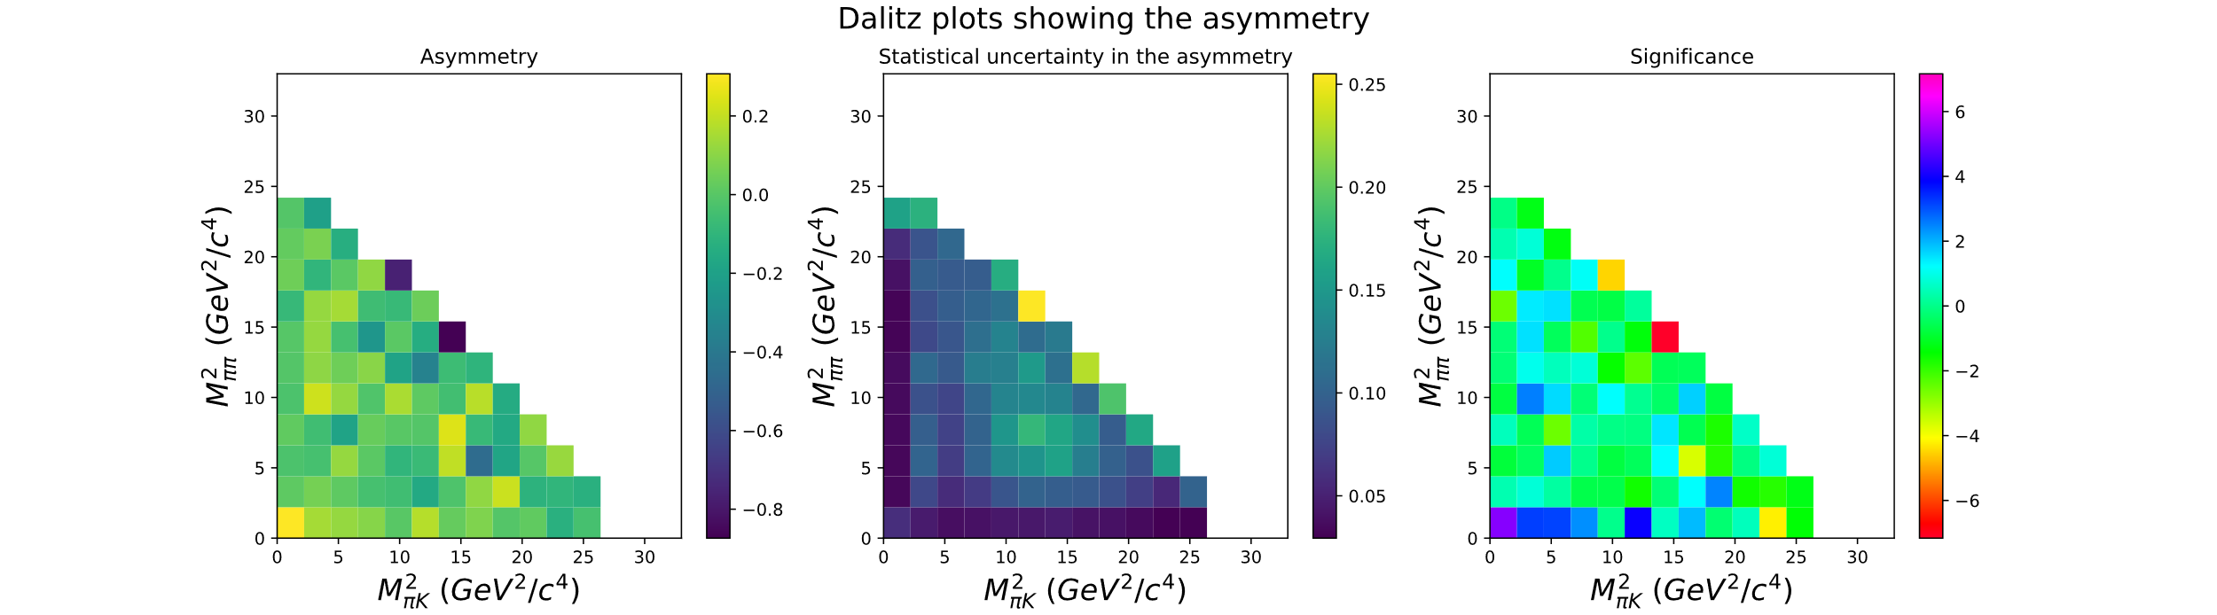We re-plotted the asymmetry with 15 bins by 15 bins or 2.2x2.2 GeV^2

|  |  |  |
| --- | --- | --- |
|  | Fitted value | Uncertainty |
| Normalisation | 77.701 | 6.824879 |
| Actual # of bins used | 85 |  |
| Mean | -0.022033 | 0.159623 |
| Spread | 1.35663 | 0.135599 |

This gives us a spread that is 2.63 sigma above where

we expect to find it.

It makes sense that the fit gets somewhat worse as there are less datapoints to be plotted into the bins. Each bin in the 2D asymmetry Dalitz plot has a lower uncertainty in general but it also makes the gaussian fit worse.

### Variable bin widths

We are going to try implement variable bins widths to improve our asymmetry plots.

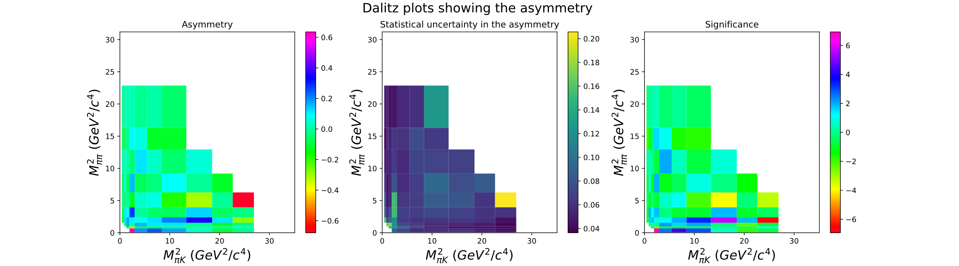We implemented variable bin widths by cutting the 1D histogram of the two body invariant masses into bins where they would all have the same number of events. This ensures that most of the 2D bins have a similar number of events and therefore uncertainty.

This in a very good improvement, it highlights areas where there is a large asymmetry.

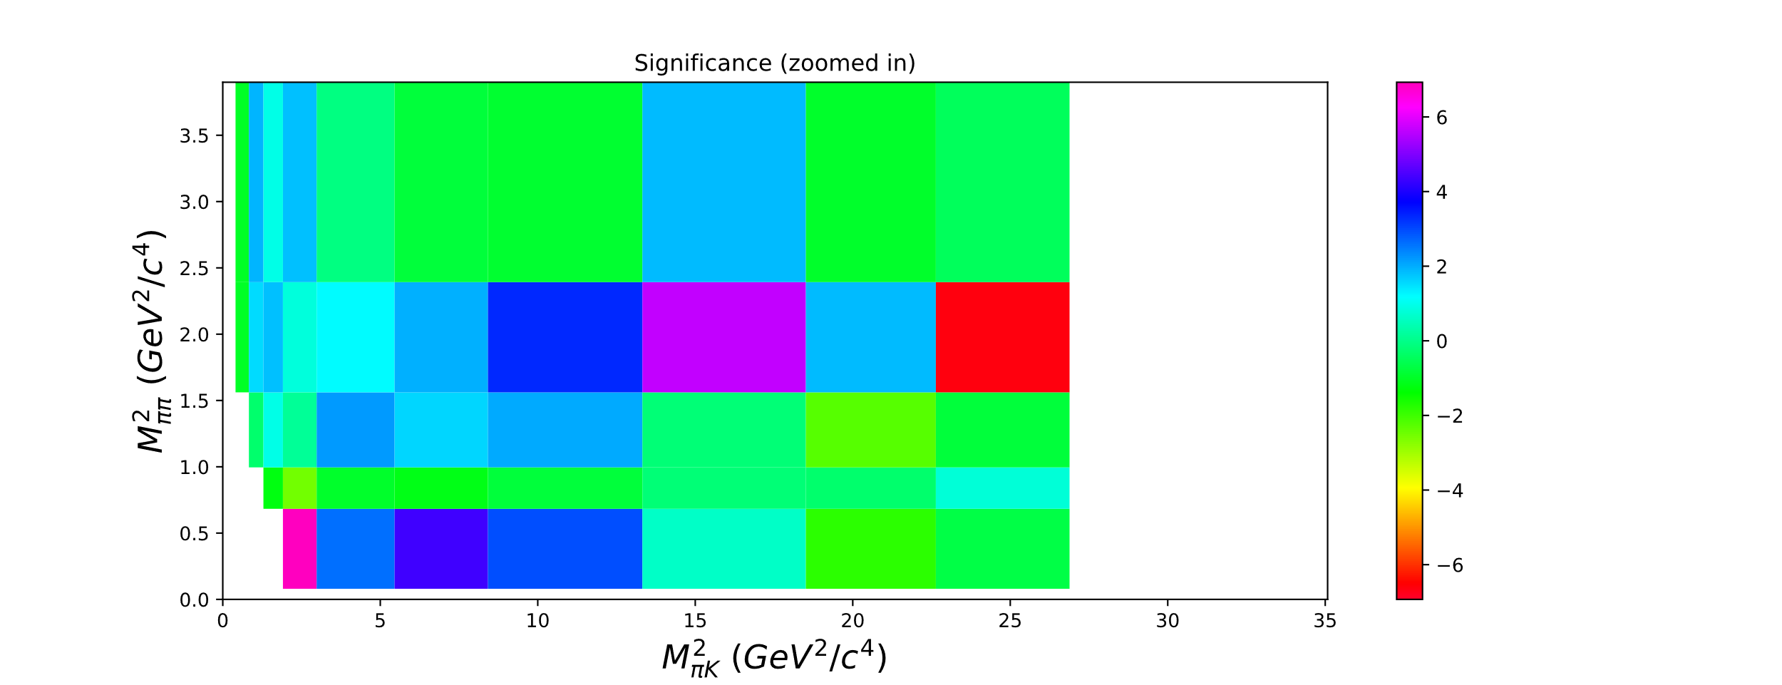

Plotting the bins from this significance in a histogram and then fitting onto a gaussian gave us

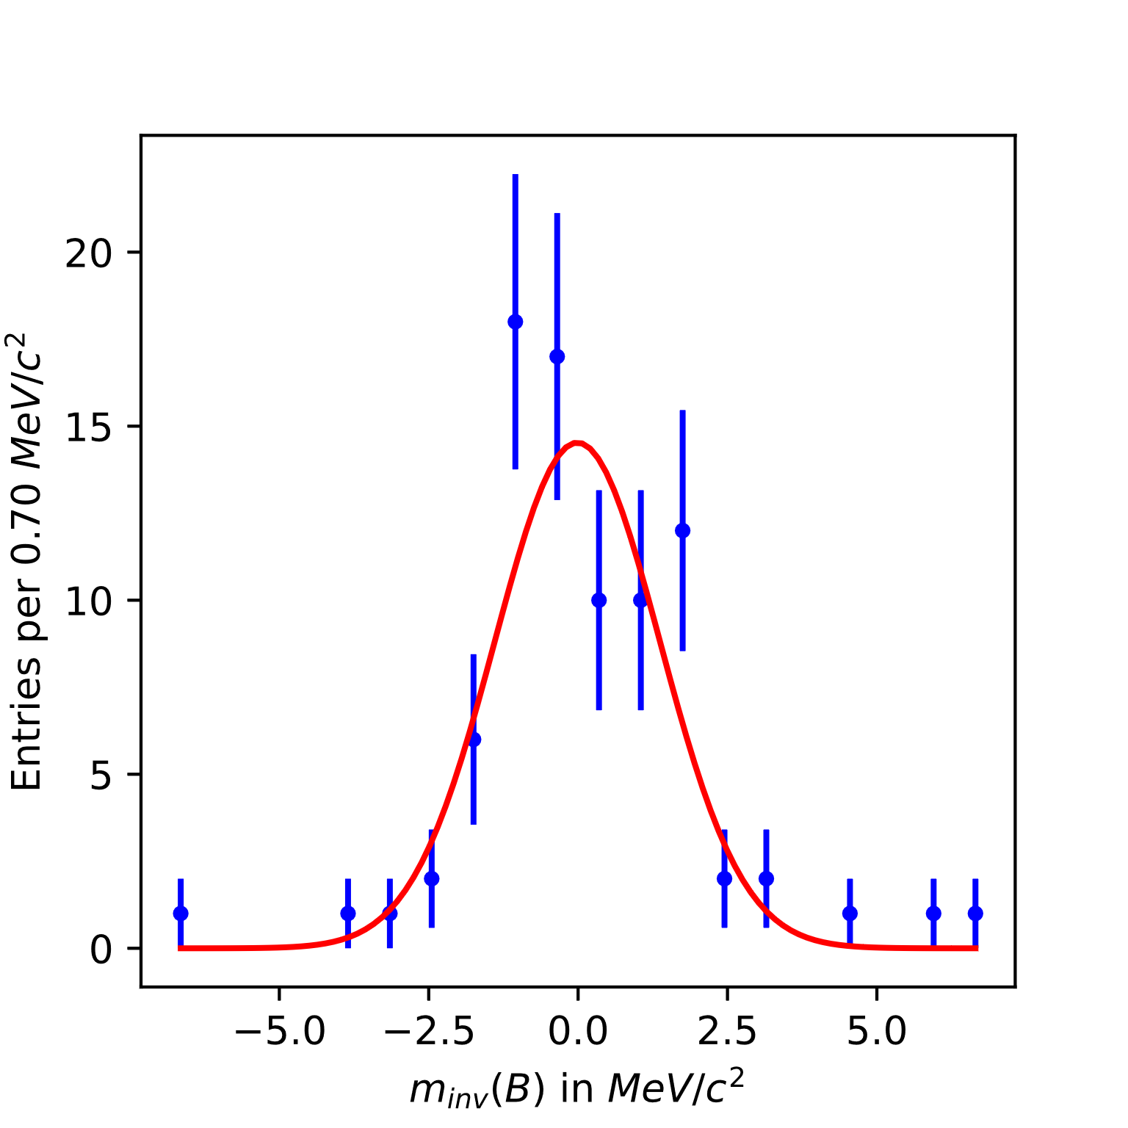

|  |  |  |
| --- | --- | --- |
|  | Fitted value | Uncertainty |
| Normalisation | 71.961 | 8.511 |
| Actual # of bins used | 85 |  |
| Mean | -0.012419 | 0.1692 |
| Spread | 1.38309293 | 0. 0.1323 |

The actual number of bins used just so happens to be same as before. I triple checked!

The spread is 3.38 standard deviations above what we would expect for no underlying CP asymmetry which is a spread of 1.

The fit is pretty terrible, so I’ll try again with more bins tomorrow.

## Week 4 day 2

04/03/21

### Variable bins Continued

We are going to repeat the asymmetry plots with smaller variable bin sizes. 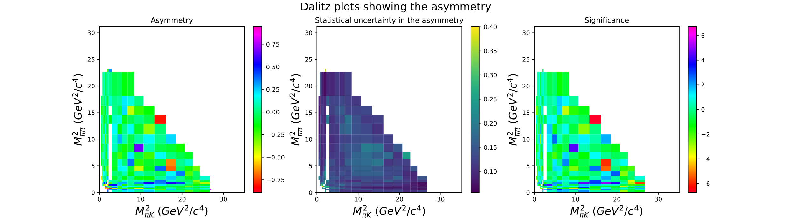

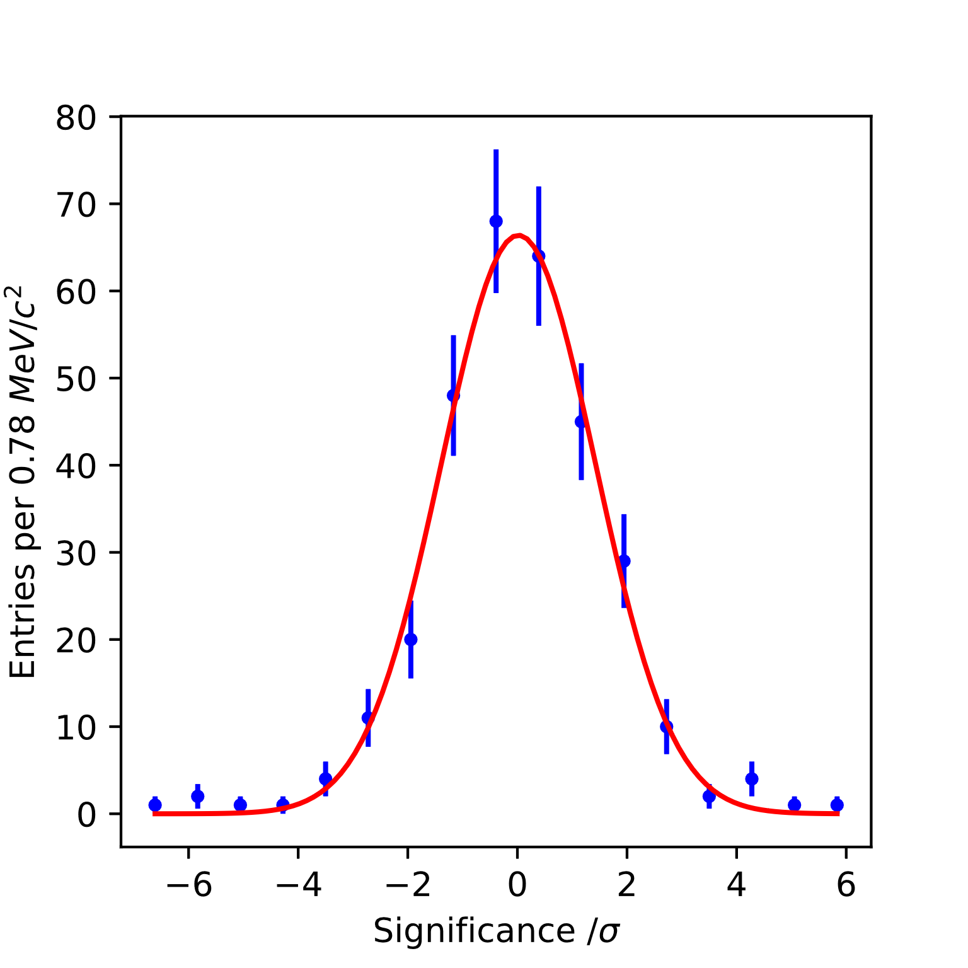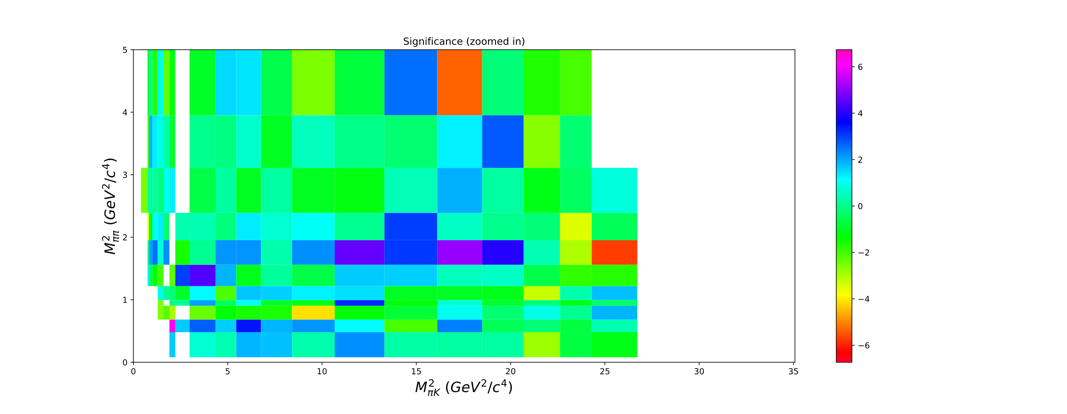The white space in the middle is due to certain boxes having negative events after extrapolating the background and subtracting it.

|  |  |  |
| --- | --- | --- |
|  | Fitted value | Uncertainty |
| Normalisation | 300.45 | 17.33 |
| Actual # of events | 312 |  |
| Mean | 0.0184 | 0.0810 |
| Spread | 1.4040 | 0.0610 |

The spread is 6.2 sigma above what we would expect to observe if

there were no underlying CP asymmetries.

### Selection criteria

We then moved onto trying to optimize our selection criteria by varying our kaon cut, P(K) and seeing how the number of signal events and background events varies. We are starting by seeing when $\frac{S}{\sqrt{S+B}}$ is maximised. We may then look into how the background is taken into account twice?

We could look further into figures of merit if we want to. Probably not worth it.

EDIT: P(Pion) = 0.6 for all these plots of us trying to maximise the signal

X-axis is the values of our P(K) cut

Y-axis is $\frac{S}{\sqrt{S+B}}$

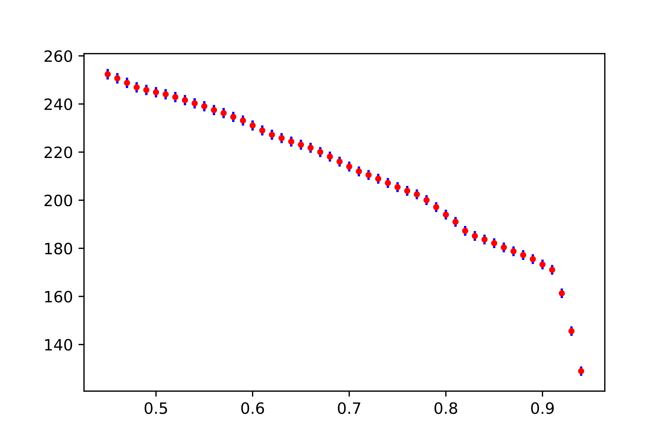

This is terrible. We were advised that it could be because our selection was accepting particles with a high P(K) and high P(pi). We made a 2D histogram plot of the probabilities of each particle being a pion or a kaon to check.

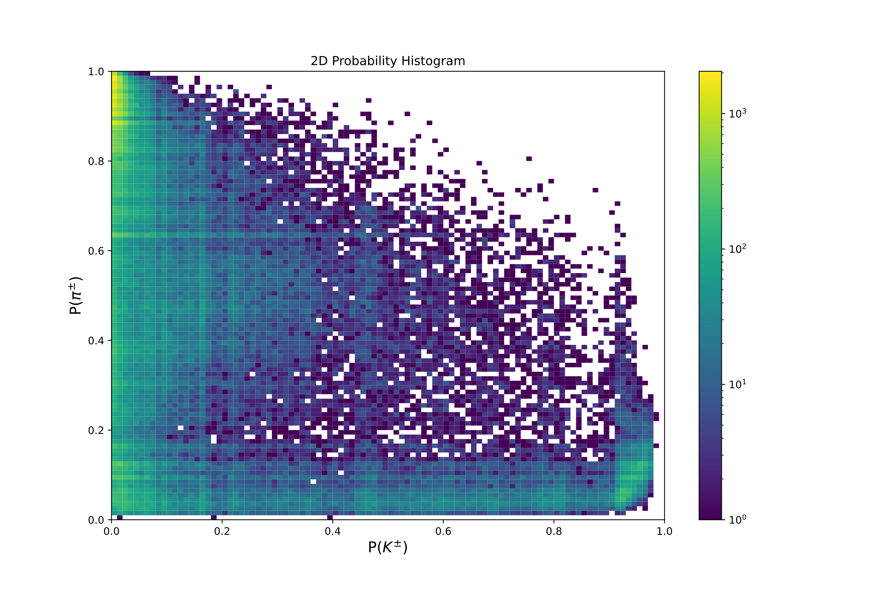

I think we were accepting too many results from the upper right corner so we made another selection cut on the particle selected as a kaon so P(pion) < 0.35 for all Kaons.

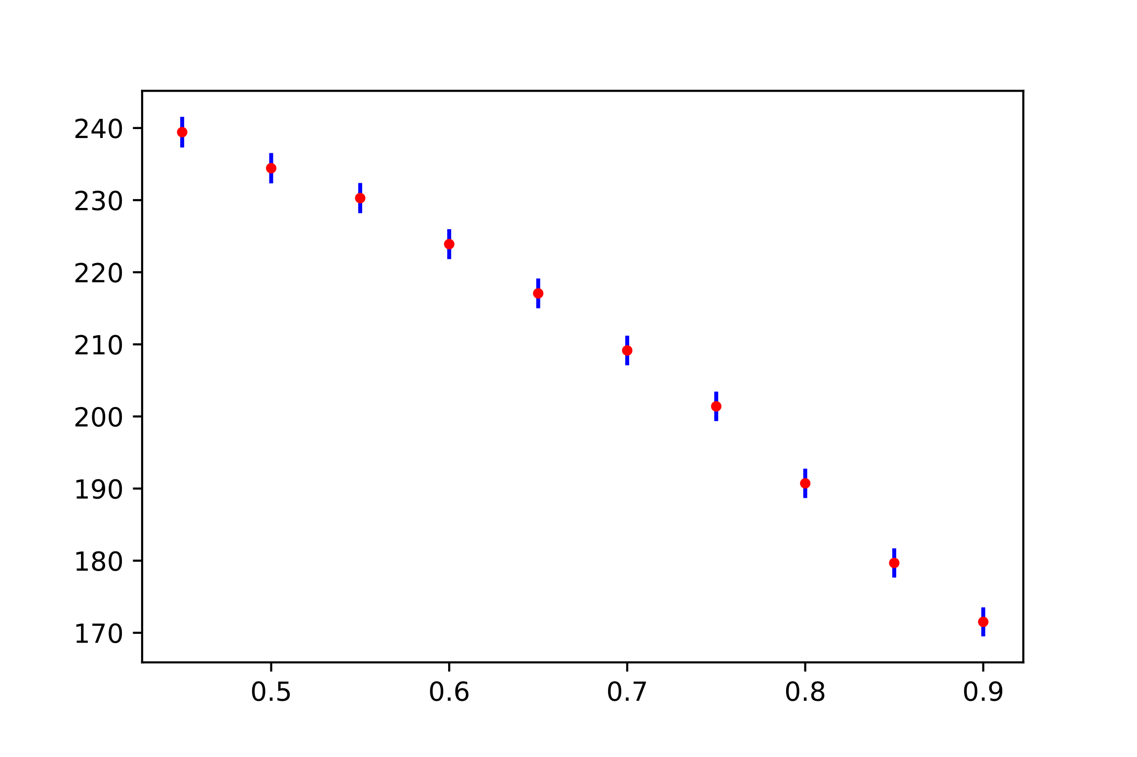

Didn’t fix it.

I realised that the exponential function that was fitted to the combinatorial background wasn’t normalised. So unlike for the crystal ball and the gaussian fit, the combinatorial’s normalization constant wasn’t equal to the number of background events multiplied by the bin width. The actual number of background events as determined by the fit, was given by

$\frac{Normilasation constant}{Bin width} ×\int_{Lower}^{Upper}{e^{-\frac{x}{λ}}} dx$

Integrating the exponential in the region from under the peak ± (4*spread) as well as the region where we plotted the background (5400 to 5800 MeV), gives us 35.8*Normalisation constant for the actual number of relevant background events. Plotting this gives us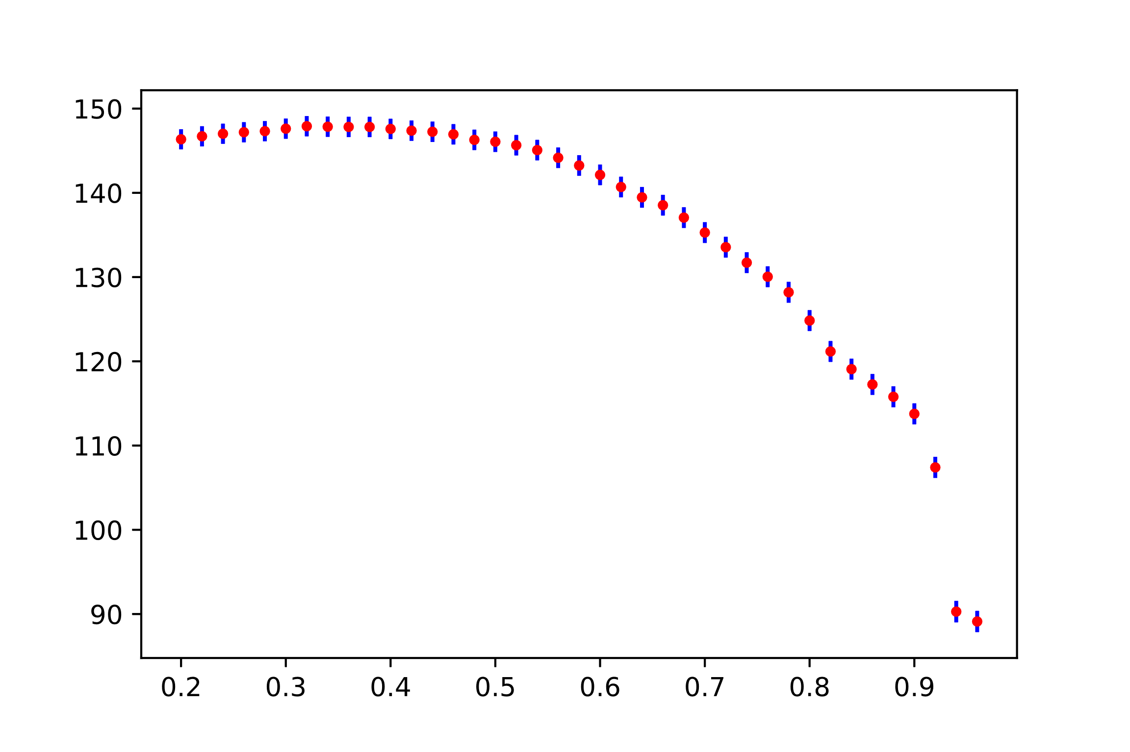

Better but the peak is at 0.32 which is wrong.

Also, seems to be a transverse momentum cut of 1.7gev in the literature [1]. We tried increasing our momentum cuts to see if it reduced background. It seemed to work so we can do a similar thing with $\frac{S}{\sqrt{S+B}}$ once we get this one to work.

The day ended here so we’ll continue this later.

## Extra work

08/03/21

I’ll do some extra work in my lab-book over the weekend

Had a programming assignment due in so I didn’t get to spend enough time on finishing this off.

### Global CP asymmetry improved

Now that we have the detection and production asymmetry and the crystal ball fit is finally working properly, we can remeasure the global CP asymmetry.

|  |  |  |  |
| --- | --- | --- | --- |
|  | Fitted value | Uncertainty | Fractional uncertainty |
| Mean (signal peak centre) | 5284.620 | 0.221819 |  |
| Spread (signal peak) | 19.502233 | 0.224207 |  |
| Norm (B+) | 13714 | 202.1 | 0.0147 |
| Norm (B-) | 13654 | 199.32 | 0.0146 |

Note that the fitted value of the mean is about 5MeV greater than the actual mass of the B+_ meson. This is likely due to some form of statistical uncertainty

This gives an asymmetry of -0.002192 or -0.22%

Statistical uncertainty ±0.6049%

The statistical uncertainty doesn’t take the uncertainty in the fits into account, which seems wrong.

We propagated the uncertainties through the asymmetry formula to get

$$σ_{A}=A\sqrt{\frac{σ_{-}^{2}+σ_{+}^{2}}{{(N_{-}-N_{+})}^{2}}+\frac{σ_{-}^{2}+σ_{+}^{2}}{{(N_{-}+N_{+})}^{2}}}$$

Using our propagation formula and the uncertainties on the fits we get an uncertainty of, ±1.01%

I’m not sure which one of these to use, or both?

Using our production and detection asymmetry value (-2.3±1.0%) to calculate the true asymmetry using this formula  gives us a true asymmetry of

$A_{CP}$ = 2.08%.

Apparently, there is an experimental systematic uncertainty of ±0.004 or ±0.4% 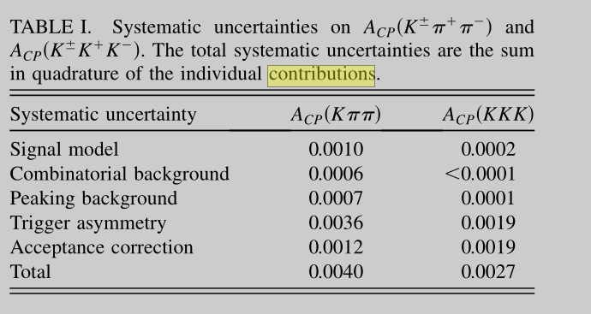 [2].

This gives us a total uncertainties of ±0.6%, ±1.0%, ±0.4%. Where the first one is statistical, second one is the uncertainty on the detection, the third one is the systematic uncertainty.

Adding these in quadrature gives us a final global CP asymmetry value of 2.1±1.2%

### Local asymmetry B+ B- plots.

According to a paper analysing the B into K pi pi decay [3] there are large local asymmetries in the rho-0 resonance region of the Dalitz plot. Just roughly looking at our asymmetries, this lines up with where some of our most significant results lie.

It’s now 10.51 pm, I will attempt to plot the rho-0 asymmetry before the deadline at midnight.

Added cuts on the invariant mass at M(PP) > 400MeV, M(PP) < 950MeV and M(KP) < 3750MeV. Note the (KP) is the ones of the opposite charges.

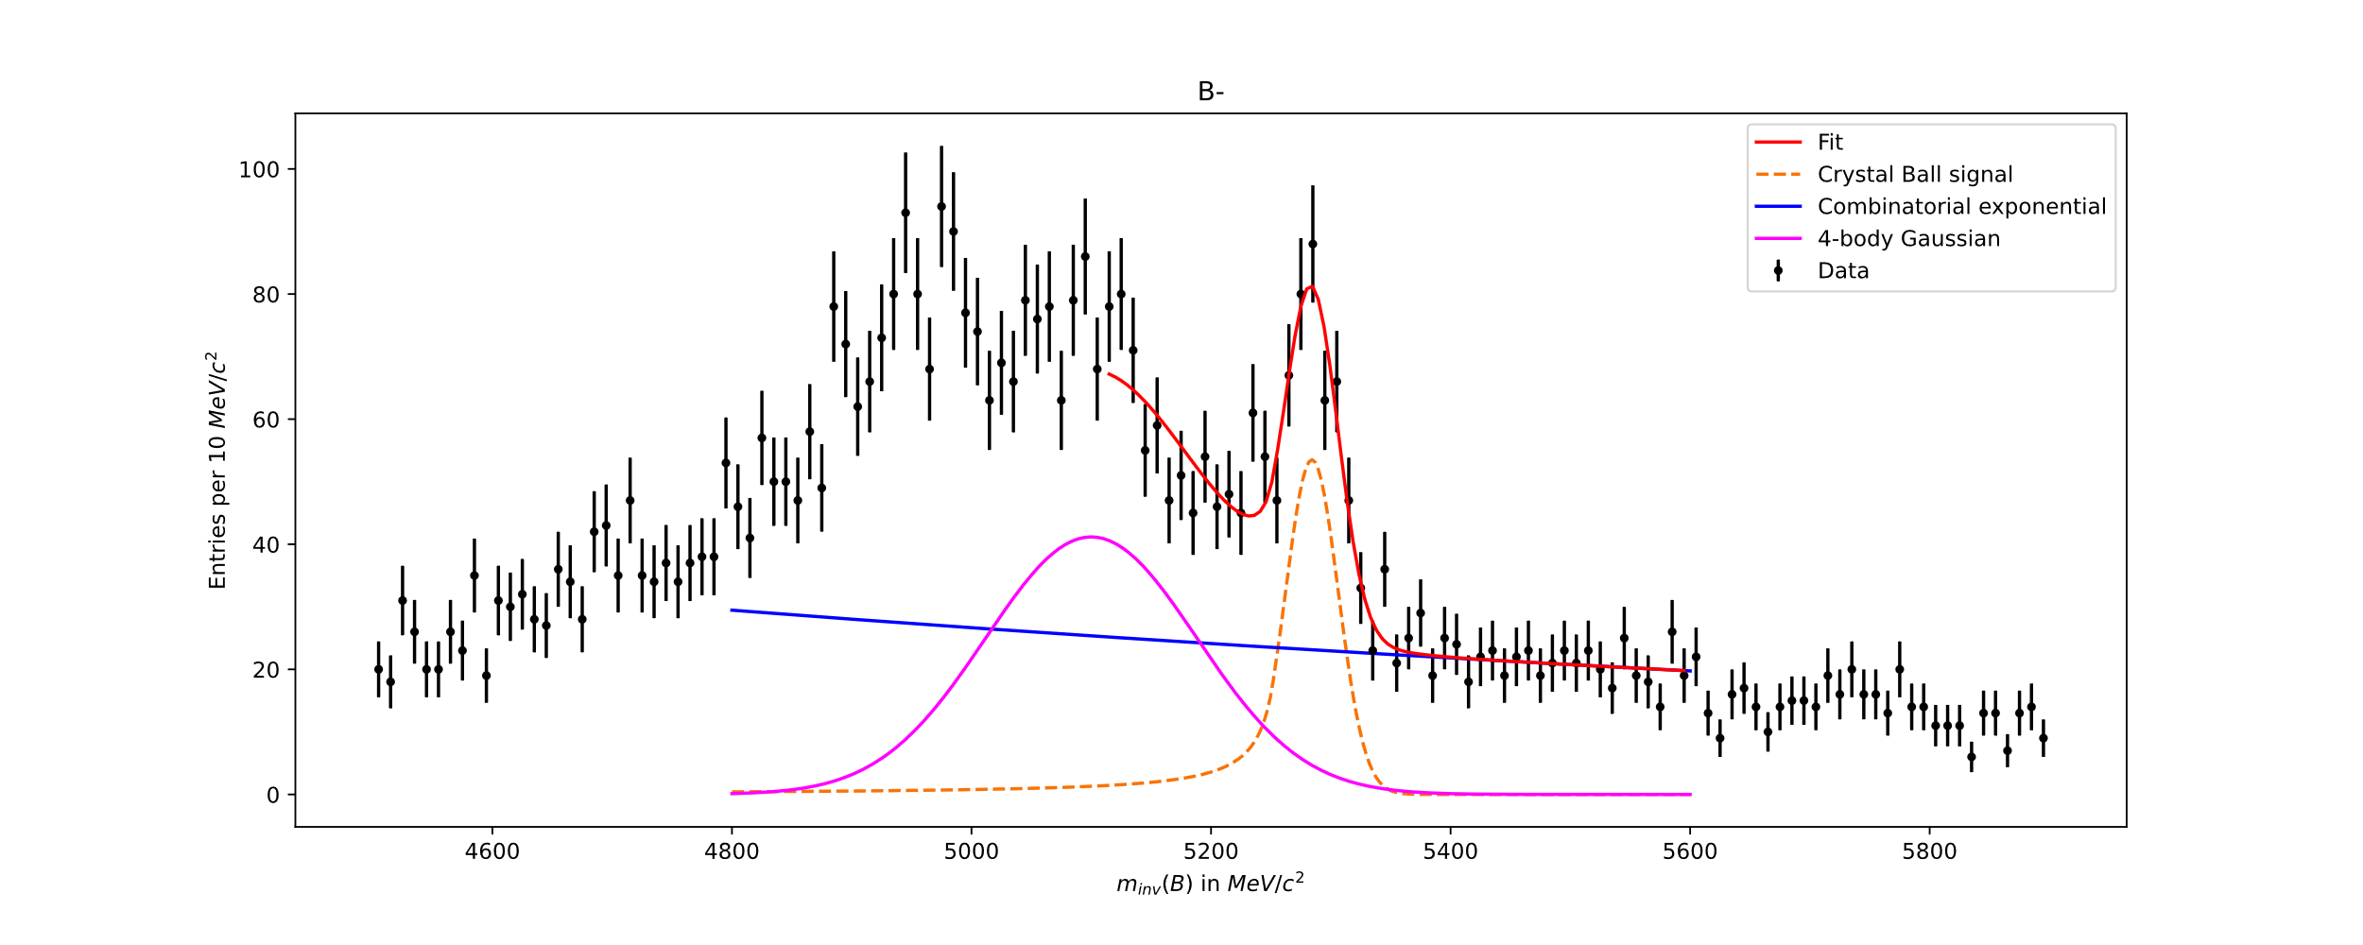My plots of the B+ and B- fits in that region.

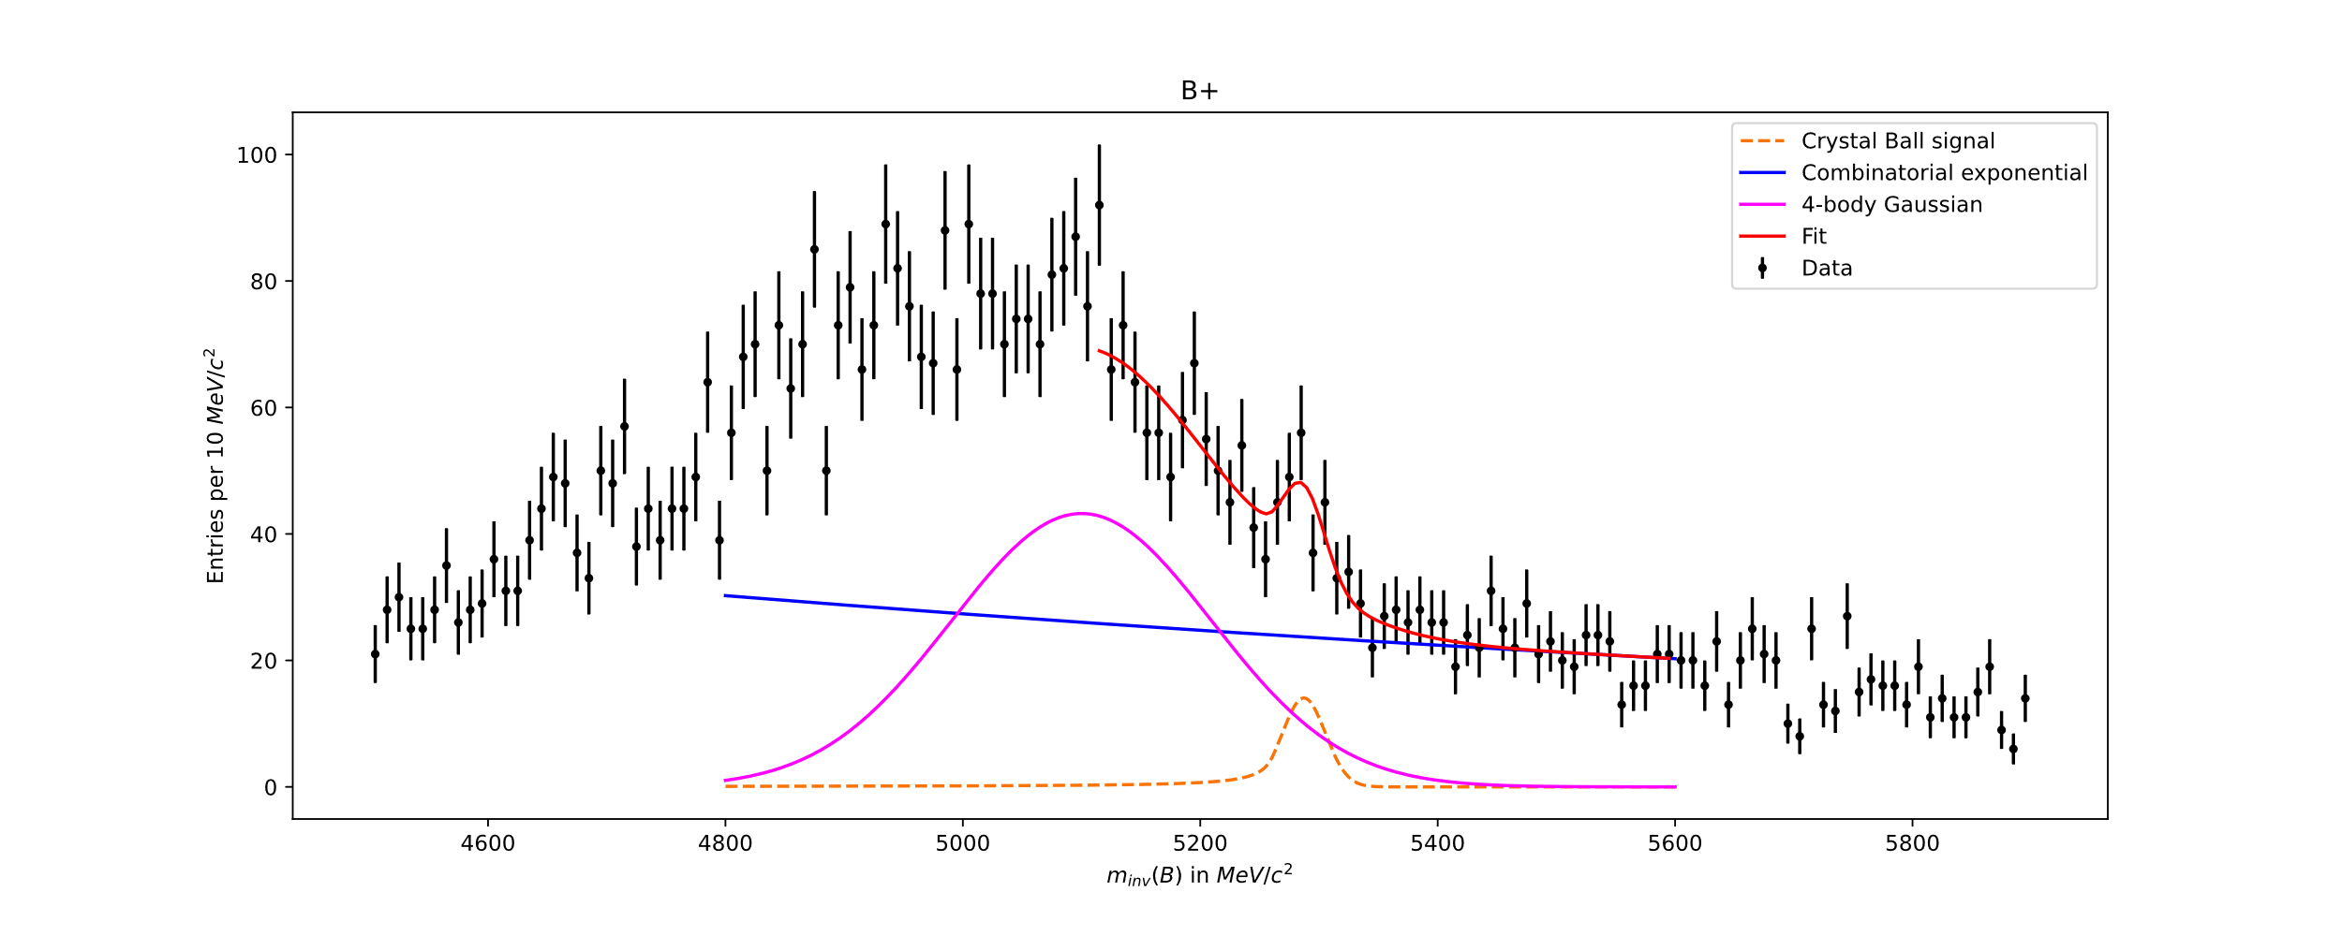

Using the fitted parameters, the B+ had 114.6±63.9 events and the B- had 532.5± 74.7 events in that region.

This gives an asymmetry of 0.646 in that region with a statistical uncertainty of ±0.03

Our error propagation asymmetry formula gives us ±0.181. (still not sure whether I should use this)

Our

Adding in the detection and production asymmetry (-0.023±0.01) gives us a total CP asymmetry in that region of: $A_{CP}$ = 0.669 ±0.01 ±0.03 ± 0.004 (± 0.181?).

I ran out of time here.

## Conclusions

08/03/21

### Global asymmetry

In conclusion we have a final global CP asymmetry of 2.1±1.2%. This value is consistent with no global CP asymmetry significant as it is only a 1.75 sigma result.

This value was found by fitting the three-body invariant mass graph with a Crystal ball for the signal, an exponential for the combinatorial background and a gaussian for the 4-body decay background. We then selected the number of events that were B+ or B- decays.

We were careful to remove resonances that either contained charm quarks as we are looking at charmless decays, we were also careful to remove resonances that decayed into muons being misidentified as pions.

We accounted for the production and detection asymmetry by calculating the raw asymmetry for the Jpsi resonance. We then compared this to a published value of the asymmetry to determine the production and detection asymmetry.

### Local CP Asymmetry

We created Dalitz plots showing the local CP asymmetry of the $B^{±}$ meson charmless decays into $K^{±}+ π^{±}+ π^{∓}$. We did this by selecting the relevant decays through analysis of two body resonance plots and by estimating and subtracting the background from the signal.

We have several areas exhibiting very significant local asymmetries in our Dalitz plots, we checked the distribution of these to see if they were just statistical noise by plotted the significance of each local area onto a gaussian.

We would expect the gaussian to be normalised about the global CP asymmetry with a spread of 1. We found the spread of the gaussian to be 1.4040±0.0610 which is 6 sigma above what we would expect for no local CP asymmetry. This very strongly implies that there is significant local asymmetry.

Also, I made a plot by isolating the rho-0 resonance and fitting the B+ and B- events to find the local asymmetry in that region more accurately. This resulted in a final asymmetry of

$A_{CP}$ = 0.669 ±0.01 ±0.03 ± 0.004 (± 0.181?). This clearly shows a very high local asymmetry.

### Extra work

Beyond the Lab script, the main parts of extra work that we did were:

* Estimating the production and detection asymmetry by analysing the Jpsi decays
* Fitting a Crystal Ball function onto our signal peak instead of a Gaussian to account for energy loss due to Bremsstrahlung radiation
* Implemented variable bin widths
* Analysed the distribution of the local asymmetry by fitting it to a gaussian and checking the spread
* Attempted to maximise the selection criteria but ran out of time.
* Made a asymmetry plot of the rho-0 resonance that exhibited a very high asymmetry

## References

[1] LHCb collaboration, R. Aaij et al., Measurement of CP violation in the phase space

of B± → K±π+π− and B± → K±K+K− decays, Phys. Rev. Lett. 111 (2013) 101801,

arXiv:1306.1246.

[2] wikipedia

[3] Aubert B et al , Evidence for direct CP violation from Dalitz-plot analysis of B±→K±π∓π±

[4] LHCb collaboration, R. Aaij et al, Search for CP violation in D+ → K−K+π+ decays